Moving and Making Progress

Thematic Unit focusing on World War I as well as Boom & Bust during the early twentieth century in North Carolina and the United States.

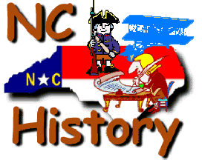

ECI 430/435
Moran/Simmons/Young
Fall 2014

Part I
Unit Title, Context & Theme

Part 1: THE TITLE, CONTEXT & THEME

Unit Title: Moving and Making Progress

A. Context for Learning
In the spring, I will be student teaching United States History with a concentration in North Carolina. I am student teaching 8th Grade Social Studies at Apex Middle School (6th-8th Grade). This school is a suburban school located in Apex, North Carolina and is a traditional public school in Wake County. My cooperating teacher has taught 8th Grade Social Studies at Apex for 6 years, since she graduated from the MSL program at NC State after student teaching at Apex Middle. She received 1st Year Teacher of the Year for Wake County in her first year of teaching, as well as Teacher of the Year at Apex Middle this past school year. This is a three-week unit that will cover World War I, The Great Depression, and Boom & Bust from the North Carolina/United States perspective.
There are common assessments between the Professional Learning Team. Wake County Public School Benchmark testing is optional, but can be used from time to time in this class. The Social Studies curriculum at this school does not go by a strict pacing plan, but does go in chronological order and makes adjustments if necessary. The cooperating teacher does use the Flipped Classroom every once in a while during units.
On a typical day in the classroom, students spend approximately 15 minutes with teacher instruction. They begin class with their warm up and having a quick class discussion about responses from the warm up. This lasts about five minutes. My cooperating teacher will administer instruction for about 15 minutes, and then for the rest of class students are working independently or collaborating and interacting in small groups on an assignment relating to the content they were instructed upon.
The length of this course is a full school year, with four core classes being taught each day that is approximately 50 minutes each. At Apex, there is no specific grouping in Social Studies classes. It is a mixed level requiring accommodations for low level and high-level students as well as variation. Students do have a PAWS (P-practice positive interactions, A-always be prepared, W-work to succeed, S-stay safe) enrichment period that I also oversee and sometimes instruct, when a group of about 30 students on my cooperating teacher’s team come back to her classroom after lunchtime for 30 minutes. This is a time for supplemental instruction, enrichment-focused activities that are grade wide or school wide, as well as time for studying or working on homework and catching up on assignments. This was created for Apex and is a school wide period that students have built into their schedule at some point during the day. With a handful of students with IEPs and 504 plans, they will have assessments and assignments with extended time. PAWS period can give students who have IEP/504 plans with extended time a period during they day where can finish those assignments or assessments that they need extra time on. Some students also have learning needs in my classes, including low readers and AIG students. The low readers will receive extra time allowed for reading and processing, and the AIG students will have higher level questioning during instruction and project differentiation.
The resources that I will use during my student teaching and when teaching my unit plan include a projector in the front of the classroom for teacher use. There also are four computers that are for student use near the teacher’s desk. There also is a cart that moves from class to class among the school with laptops. There is a class set with enough computers for 32 students to use. There is Smart Board accessibility and Document Cameras that can be checked out in the Media Center. There are four cameras that can be checked out by students for the Flipped Classroom experience. I plan to use some of these resources, as well as refer to the text The American Journey, Glencoe-McGraw Hill 2008 when necessary. My cooperating teacher rarely uses the textbook, so I plan to not use it much when I am student teaching, if even at all.

B. Organizational Principle
Theme: Sacrifice to Success
I decided to choose the theme of sacrifice to success based on the way that sacrifices were made during each portion of the time periods covered in this unit. Americans were dealing with sacrifice when they entered the First World War and had to send troops overseas. They dealt with sacrifice by having to give up and deal with the amendments and laws set in place during the Roaring Twenties. They had to learn to adapt with the failing economy during the Great Depression, and had to sacrifice by changing their ways when Boom & Bust occurred and the New Deal was established to improve the nation. My students will be able to see how sacrifice turned into success over roughly twenty years for the United States, as well as how that affected our state of North Carolina. They can relate this to their own lives by seeing how sacrificing childhood and giving up being young can lead to large changes, like moving to high school, on to college, and eventually starting a career. For example, students have to give up trick or treating on Halloween or not believing in Santa Claus anymore in order to grow up and move forward in adolescence. They also may have to sacrifice hanging out with friends after school or watching an extra amount of television in order to complete their homework assignments on time. I am interested to see this thematic unit unfold as students learn about the different events that occurred for the United States and North Carolina during the early twentieth century. I have included several interactive group activities for students to participate in as well as engaging warm-ups to coincide with the work that they will complete for that day.

C. The Content Focus
World War I, Boom & Bust
This unit will be focused on three historical areas of content that occurred in United States History. The first section will be about World War I from the United States standpoint, with a focus on the sacrifice that soldiers had to make when going overseas, what kind of sacrifices this created for the home front, etc. The second section will be about Boom & Bust, including causes and effects of the roaring twenties, the depression, what United States and North Carolina specifically had to sacrifice in order to survive the depression and the laws set forth in the twenties. The third section of the unit will be focused on Bust, covering the Great Depression, the New Deal and progression after the depression. All sections of the unit will cover major leaders during this time period that were influential to the United States and what impact these time periods had on the United States and North Carolina politically, socially, and economically. Students will build their vocabulary of the unit through different in class activities and instruction. This will give students a grasp on what World War I and Boom & Bust meant for our country and how the trend of sacrifice carries throughout the unit. Students will also be able to relate to current events happening in today’s society or recently in United States history that connect to war, economic hardships, and continuing to improve the country.

D. Organizing Questions

- What can we sacrifice in order to make our world around us a better place?
- What can we learn from the negative and positive events in history for the future?
- What sacrifices do individuals, communities, states, nations, and the world make?
- What type of sacrifice do you see occurring in your own life?
- How can we as individuals sacrifice for our country or a larger nation?
- How can we relate events that occurred in World War I and Boom & Bust to our society and world today?

E. Goals
My students will be able to:
- Relate the sacrifices in history to sacrifices of today and the future
- Understand what was happening during a period of major change and rebellion in the United States
- Reflect on what they are giving up as they mature in their middle grade age
- See the ups and downs of the early twentieth century
- Relate to the time period learned from collaborative activities
- Explain their own opinions about decisions made during the time period studied
- Relate events and facts of the time period their lives or emotions

F. General Unit Objectives
Overall Objectives:
Cognitive:
- Analyze information from different sources
- Understand the different meanings of sacrifice and success
- Identify sacrifice and success in unit and students’ own lives
Affective:
- Participate effectively
- Expresses self creatively
- Collaboratively work in groups
Performance:
- Present material through different mediums
- Compose in various forms of assignments/activities
- Demonstrate understanding of content learned

Common Core: Social Studies
- CCSS.ELA-Literacy.RH.6-8.1 Cite specific textual evidence to support analysis of primary and secondary sources.
- CCSS.ELA-Literacy.RH.6-8.2 Determine the central ideas or information of a primary of secondary source; provide an accurate summary of the source distinct from prior knowledge of opinions.
- CCSS.ELA-Literacy.RH.6-8.4 Determine the meaning of words and phrases as they are used in a text, including vocabulary specific to domains related to history/social studies.
- CCSS.ELA-Literacy.RH.6-8.7 Integrate visual information (e.g., in charts, graphs, photographs, videos, or maps) with other information in print and digital texts.
- CCSS.ELA-Literacy.RH.6-8.8 Distinguish among fact, opinion, and reasoned judgment in a text.
- CCSS.ELA-Literacy.RH.6-8.9 Analyze the relationship between a primary and secondary source on the same topic.

Essential Standards: Social Studies
- 8.H.2.1 Explain the impact of economic, political, social, and military conflicts (e.g. war, slavery, states’ rights and citizenship and immigration policies) on the development of North Carolina and the United States.
- 8.E.1.1 Explain how conflict, cooperation, and competition influenced periods of economic growth and decline (e.g. economic depressions and recessions)

G. Possible Unit Materials & Supplementary Texts
(* Signifies that I will definitely be using these materials and texts in my teaching)

Primary Documents
- The Zimmermann Telegram*
  - http://www.archives.gov/education/lessons/zimmermann/
- Soldiers in World War I*
  - http://www.eyewitnesstohistory.com/ambulanceservice.htm
  - http://www.nysm.nysed.gov/citizensoldier/conflicts/WWI/pschaming.cfm
  - http://www.slate.com/articles/arts/history/2013/05/world_war_i_veteran_the_last_of_the_great_war_s_soldiers_speak.html

Text
- Chronicle of America, Chronicle Publications 1989*
- The American Journey, Glencoe-McGraw Hill 2008*
- The United States in the 20th Century, Rubel Scholastic Reference 1995*
- The Kids Guide To Social Action, Free Spirit Publishing Barbara A. Lewis 1991

Music Resources
- Over There! By: George M. Cohan*
  - https://www.youtube.com/watch?v=B6hRDS3LvQQ
  - http://www.lyricsmania.com/over_there_lyrics_george_m_cohan.html
- Meditative Music*
  - https://www.youtube.com/watch?v=qrx1vyvtRLY

Pictures
- Various pictures from The United States in the 20th Century (pp. 38, 46-51, 55, 61)*
- Various pictures from Chronicle of America (pp. 602, 640-641, 645)*

Websites
- Great Gatsby Official Trailer*
  - https://www.youtube.com/watch?v=rARN6agiW7o
- Introduction To World War I Video Clip*
  - https://www.youtube.com/watch?v=8UcvJi8klz8
- World War I Weaponry*
  - http://www.firstworldwar.com/weaponry/index.htm
- Wordle*
  - http://www.wordle.net/create
- VoiceThread*
  - http://www.voicethread.com
- United States Recession Article*
  - http://money.cnn.com/2008/12/01/news/economy/recession/

Technology
- Computer*
- PowerPoint*
- Portable Computers*
- Videos*
- Online Tools (Kahoot, Wordle, VoiceThread)*

Aesthetic Materials
- Pencils/pens*
- Markers*
- Colored pencils
- Highlighters*
- Paper*
- Posters*
- Computers*
- Printer*
- Graphic organizers*
- Notes*
- Whiteboard Markers*
- Sticky Notes
- Newspaper Articles*
- Propaganda Examples*

H. Possible Activities/Instructional Strategies
(* Signifies that I will definitely be using these activities in my teaching)
- Written Warm Ups*
- Wordle Vocabulary Warm Up*
- Class Discussion*
- Primary Documents*
- Group Collaboration*
- Portable Laptops*
- Music*
- Popcorn Reading*
- Socratic Method Debate*
- Exit Tickets*
- Jigsaw Groups*
- Guided Notes Sheets*
- Activity Sheets*
- Moving around the room*
- Timelines
- Writing/Reading Activities*
- Kahoot Review Game*
- Interactive Movement
- Amendment Skits*
- VoiceThread*
- Roaring Twenties Fashion
- Propaganda Posters*

I. Unit Map/Narrative Overview
Rationale:
The reason that I have chosen to create and design the lessons that I did that are related to the curriculum are based on the nature of the students in my class. Students in my classes do not like coming into class and doing the same thing every day. They seem to like a routine, but have different activities to learn. This is the reason that I varied how they would learn the material from the Sacrifice to Success unit. If there is a lot of information to get covered in one lesson or a short amount of time, I made a PowerPoint for them to refer to as they took notes. If the students had activities or group work to complete to learn the material, I made sure they had a guided handout if needed. If it were not necessary, I would let them complete the activity and then give them a handout to study from at the end of class. I tried to incorporate technology with videos, music, and through their unit projects. I also tried to vary activities that they would be doing to help them better remember the material and not just take notes every day that they are in class.
My students who have IEP and 504 plans should be able to follow along with group activities and assignments given to them. However, they will have their guided notes already filled in if necessary and other accommodations if needed. I am hoping that my students are excited and eager to learn about an interesting time period in United States history and make the connections with it and sacrifice. I decided to make a unit project for students to have free reign about what they wanted to research during this time period in United States history and due to the large amount of information, it would have been hard to cover this all in a unit test. I did have a quiz about World War I before moving on to the Roaring Twenties, Great Depression, and New Deal material. I thought this would be a good way to break up the material and to have a formal assessment about whether they understood the information or not. I am hoping that my students make the connections with sacrifices they have had to make in their own lives to some of the sacrifices that were made during the time period of this unit. I have worked extremely hard on this layout and reasoning for putting certain lessons on certain days, matched with specific activities. I am hopeful that my students are able to take a great deal of information from this thematic unit.

Day 1: Sacrifice to Success Introduction of Unit
- Warm Up (8 minutes)
- Students will come into class and update their Table of Contents (way of organizing their binders for Social Studies) and write the homework for the day in their notebook. The warm-up is always projected onto the board from a computer. (2 minutes)
- Warm Up: “Write down a couple of ideas or thoughts that come to mind when you hear the event, World War I. Be prepared to share with the class.” (3 minutes)
- Review warm up. Have students share their answers and explain that over the course of the unit they will be able to significantly expand their knowledge about The Great War. (3 minutes)
- Hook – Introduction to Unit (12 minutes)
- Sacrifice-What kinds of sacrifices have you had to make in your life? Have students complete a think-pair-share for this question. (7 minutes)
- Show Introduction to World War I YouTube Video Clip to give students some exposure and visual about World War I. (3 minutes)
- Explain that this is one of the many sacrifices that were made and that there were several others also made during this unit, which will be touched upon over the next few weeks. Students will be given an assignment towards the end of the unit relating sacrifice to the unit and their own lives. (2 minutes)
- Instruction – What’s Happening in the United States? (22 minutes)
- Students will follow guided notes about pre-World War I and what was happening to cause United States entry into World War I. This will be a PowerPoint presentation with a few fill in the blanks for students to fill in as they pay attention. Questions will also be prompted while going through the PowerPoint for student participation. The PowerPoint will have many of the vocabulary terms students will be expected to know. Other definitions will come throughout the unit.
- This presentation will be done to cover a lot of information in a short amount of time. (20 minutes)
- Tell students there will be a group activity tomorrow based on what caused President Wilson to enter the United States into the war. (2 minutes)
- Conclusion – Wrap up/Exit Slip (8 minutes)
- Finishing up the guided notes, remind students that for homework they should be reviewing their notes and activities in class each night. Tonight, they should review their guided notes that were completed in class today and be thinking about how the United States would enter the war. (1 minute)
- Students will complete an exit slip and turn it in at the end of class, describing one thing they would like to learn more about with World War I. They will turn this into the basket on the way out the door when class is dismissed. (4 minutes)

Day 2: What Happens Next?
- Warm Up (5 minutes)
- Students will come into class and update their Table of Contents and write their homework assignment into their agenda. (2 minutes)
- Projected onto the board will be the warm-up, “What would you do if you were in President Wilson’s shoes? Would you declare war and involve the United States or stay out of it? Explain.” (3 minutes)
- Bridge (5 minutes)
- Discuss with students what their responses were to the warm up. What would they have done if they were President Wilson and had to make a decision that would change the future of the United States? (4 minutes)
- Listen to student responses and discuss different viewpoints that certain students have. Possibly even give your own opinion to share with students. (1 minute)
- Instruction – How did it happen? (10 minutes)
- Give a description and have students fill in the end of their guided notes about how President Wilson entered the United States into World War I. (7 minutes)
- Explain to students what the Zimmermann Telegram was and what this meant to certain countries. (3 minutes)
- Activity (25 minutes)
- Give each group a copy of the Zimmermann Telegram primary documents to answer questions and analyze. (2 minutes)
- Students will go through the questions as a group and give their responses. Groups will work with assignments. The group leader will be the one prompting and asking the questions. The two researchers of the group will look for answers and understand the documents. The last group member will be the recorder, writing down the group’s responses. (10 minutes)
- Walk around as students are working in groups, listening for what their answers are to the critical thinking questions.
- Explain to students that they will turn in their activity sheet and I will make copies for each group to place in their Table of Contents.
- After answering the small list of questions, explain to students that they will make their own code and come up with a telegram to send to a friend. This will be turned in tomorrow at the beginning of class and will be homework if they do not finish in class today.
- Wrap Up (5 minutes)
- Bring students back together and have them pay attention for last minute announcements. (2 minutes)
- Have students finish their telegram codes and to name them their last name, code. For example, “Scruggs Code”. Tell students that they are to finish for homework and turn in at the beginning of class. (2 minutes)
- Students will turn in their group activity sheets for an activity completion grade as they exit class. (1 minute)

Day 3: Where do we go from here?
- Warm Up (5 minutes)
- Students will come into class and update their Table of Contents and turn in their codes they created for homework to their select period bin. At this time, I will handout copies of the Zimmermann Telegram Group Activity for each student to have from their group’s notes to study for the test. (2 minutes)
- Warm Up (projected on the front board): “If you had something that you were trying to recruit people for (a club, sports team, etc.), how would you go about trying to get individuals to sign up? Give a few examples and explain.” (3 minutes)
- Bridge (3 minutes)
- Go over the warm up and ask students what their answers would have been. Then ask them the larger picture about what they would do if they were recruiting soldiers for war. These soldiers may not have had any prior experience or any training to go war. How would you get them to join? (3 minutes)
- Instruction/Group Activity (27 minutes)
- Explain to students what propaganda is and how this correlated with ways that the United States had to get individuals to sign up for the war effort. (3 minutes)
- Tell students how many people President Wilson had to draft to go overseas, and include how many North Carolinians went overseas. Over 4 million were drafted to go fight. (3 minutes)
- Students will complete a group activity, each being assigned to come up with their own poster of propaganda to recruit for the war. (15 minutes)
- Posters students complete will be displayed around the room during the Sacrifice to Success unit.
- Have groups share their posters and explanation of what they put on their poster and why they put certain things on it. (6 minutes)
- Pulling It All Together (15 minutes)
- Have groups turn in their posters. This will count as a class work grade. (2 minutes)
- Explain that posters were not the only way to get citizens involved in the war. Music was another way, and “Over There” by George Cohan was a popular song that they played at the time to get people involved. Hand out lyrics sheet to “Over There” by George Cohan for students to refer to. (3 minutes)
- Play “Over There” YouTube video to the class for them to hear before class ends, explaining the next step was warfare and we will discuss it in class tomorrow. (10 minutes)

Day 4: World War I Warfare
- Warm Up (5 minutes)
- Students will come into class and update their Table of Contents. The song “Over There” will be playing during the warm up and as students walk in to refresh memories about what we talked about the previous day. (3 minutes)
- Warm Up: “What do you predict were some of the weapons that were used in World War I that had not been used before?” (2 minutes)
- Activity (25 minutes)
- Explain to students that they will complete a Jigsaw Activity to learn in depth about different types of warfare that were used in World War I. (5 minutes)
- Each group will be given a specific type of warfare. They will use the resource sheets provided to learn about warfare (World War I Weaponry). Once the groups have become knowledgeable of the topic, they will move to another group and share with each other what they learned about different weapons. They will fill in their guided sheets about warfare to keep for their notes. (15 minutes)
- Have students go back to their groups and share what they learned and prompt class discussion about weapons during war. (15 minutes)
- Instruction (10 minutes)
- Explain to students their “Sacrifice to Success” unit project instructions. Pass out the handout explaining the project as well as the rubric attached so they can see how they will be graded on the assignment. Explain that this project gives them many options and they will be given some time in class to either work on the project or as any questions that they may have.
- Explain to students that they can begin the project but may want to research a topic that we have not yet covered until towards the end of the unit. If they want to do some prior research, they are more than welcome to do so.
- Wrap Up (10 minutes)
- Explain to students that they should be holding onto their notes sheets and activity sheets to reference to study for their World War I quiz that will be given next week to culminate this portion of the unit. (2 minutes)
- Remind students to be thinking about a time in their lives when they had to sacrifice something and that they will use this for their final sacrifice unit project due in a couple of weeks. (3 minutes)
- For homework, have students be thinking and brainstorming about what was happening to the soldiers during the war overseas. They should bring in a list of three ideas that they believe were going through a soldier’s mind to share in the warm up for class tomorrow. (5 minutes)

Day 5: Soldiers in World War I
- Warm Up (5 minutes)
- Students will come into class and update their Table of Contents. (1 minute)
- Warm Up: “What do you think it was like for soldiers who had to leave their families and sacrifice their lives for their country? What do you think they had to sacrifice when they left the United States for war? Use your list from homework last night and discuss with your groups.” (4 minutes)
- Instruction (25 minutes)
- Explain to students about the soldiers in World War I and how they were recruited. Hand out the guided notes for their understanding. (3 minutes)
- On the computer displayed on the projector, pull up three primary documents (Soldiers in World War I) and explore them with students. Ask questions and explain what these soldiers went through from overseas. Ask which soldier they would most likely relate to. Ask what they would do if they were in the soldiers’ situation. Prompt them to think about the sacrifices that they had to make for their families and their country. Tell them that soldiers going overseas have not changed and that there are still soldiers fighting for our country today. (17 minutes)
- Show on a map where these soldiers fought and how the United States was involved in the war overseas. (3 minutes)
- After class discussion, pass out a handout for students to be able to study from with notes about each of the primary source documents about World War I soldiers for them to reference. (2 minutes)
- Activity (15 minutes)
- Have students write a letter to a soldier in Iraq about their experiences and what they have been learning about and that they are proud that people like them are out fighting for our country. Explain to them that you will try to get in contact with someone to send the letters off to, because soldier appreciate letters of encouragement like the ones they are writing. (10 minutes)
- Play peaceful music as students are writing their letters for independent work.
- Wrap Up (5 minutes)
- Remind students to hold onto their handouts to study for their World War I quiz. (3 minutes)
- Tell students to finish writing their letters to a soldier for homework. (2 minutes)

Day 6: Life On The Home Front
- Warm Up (5 minutes)
- Students will come into class and update their Table of Contents. (1 minute)
- Warm Up: “Predict!! While some are overseas fighting for our country, what was everyone on the home front doing back in the United States during this time?” (4 minutes)
- Activity (35 minutes)
- Connect the warm up to the activity for the day explaining that they are going to learn what people were doing. Give instructions to the group activity. (5 minutes)
- Each group will be given a different person to begin (men, women, children, business owners, etc). They will have 5 minutes to read as a group and come up with an assumption about what this type of person did in the United States during the war. Have them fill in their “People on the Home Front” sheet as they go through the notes. They should be filling out their notes sheet individually for future reference. After five minutes, they will switch people with the group to their right in a circle until everyone has seen each individual. (30 minutes)
- Walk around and monitor that students are staying on task and gathering the correct information about the individuals.
- Wrap Up (5 minutes)
- Write on your warm up whether your prediction was correct or not and why or why not it was correct. (3 minutes)
- For homework, make sure to fill in any information that you may have missed about the people on the home front during World War I. (1 minute)
- Remind students that their World War I quiz is in four days and to be taking notes efficiently and staying on task in class as we are covering a large amount of information in a short period of time. (1 minute)

Day 7: How Did It All End?
- Warm Up (5 minutes)
- Students will come into class and update their Table of Contents. (1 minute)
- Warm Up: “Have you ever been in an argument or fight with someone? What did you do to resolve it? Explain.” (4 minutes)
- Bridge (5 minutes)
- Discuss with students their responses to the warm up. (1 minute)
- Relate what their responses were to the war. On a larger scale, do the ideas seem like a way that a war could be ended? Receive students’ thoughts as you hand them their sheet “End of War” to take quick notes on. (4 minutes)
- Instruction (15 minutes)
- Go through storytelling to explain how the war ended. Tell students to use their notes sheet and feel free to add any side notes in the margins as I explain how the war ended to them. (12 minutes)
- Tell them to keep these notes to refer to and to study from for their quiz tomorrow. Let them know that because they just learned a little bit of new material today, there will not be as many questions on the quiz from this section of notes, but more heavily on earlier notes and handouts from the unit. (3 minutes)
- Wrap Up (25 minutes)
- Review with Kahoot for World War I quiz tomorrow. Explain to students how to use Kahoot and to pull out their portable laptops or mobile device. Have them type in the quiz access code and be ready to participate.
- For homework, tell students to study for their quiz on World War I tomorrow. Remind them to review all graphic organizers, notes, and handouts from the unit so far. Have them be prepared to answer one short answer question about sacrifice.

Day 8: Quiz/Amendment Skits
- Warm Up (2 minutes)
- Students will come into class and update their Table of Contents.
- No Warm Up. Prepare for quiz.
- World War I Quiz (20 minutes)
- Students will independently complete their World War I quiz.
- If students finish early, they can turn it into their core bin and work quietly on other homework or read a book.
- (IEP students who need extra time may come in during PAWS time to finish and complete)
- Amendment Changes (27 minutes)
- Explain to students the different amendments of the time that were passed during this time period. (7 minutes)
- Give each group a different amendment and have them create a short skit to demonstrate these amendments to the class. Skits should be a minute or two in length and a good representation of what they meant for the United States. Walk around the room as students create their skits and ask if they have any questions as you walk around. (10 minutes)
- Students will present their skits as groups. Students watching can write down their peer’s skits next to the amendment numbers to refer to. Skit presentations will count as a class participation grade. (10 minutes)
- Wrap Up (1 minute)
- No homework for this evening. We will start learning about life after the war for the United States in the next couple of days.

Day 9: The Roaring Twenties
- Warm Up (5 minutes)
- Students will come into class and update their Table of Contents. (1 minute)
- Warm Up: “Have you ever heard of the Roaring Twenties? If so, explain what you know about it. If not, explain what you think it might be and what you would like to know about it.” (4 minutes)
- Instruction (7 minutes)
- Play the YouTube video clip of the beginning of The Great Gatsby movie trailer when Tobey Maguire is describing what life was like in the 20s. Explain to students what the Roaring Twenties was and how this was a time of progression for the United States after coming home from war.
- Activity (35 minutes)
- Roaring Twenties Gallery Walk: Instruct students that they are to walk around to the different displays and descriptions posted variously around the classroom (pictures from Chronicle of America). Have them write what they notice about the different artifacts. Have them stay at each display for about 3-4 minutes before having them rotate in groups. (20 minutes)
- Have students come back to their seats and have a discussion about the artifacts that they saw and how they thought that it related to the Roaring Twenties. Explain what each of the artifacts are and how they connect to the Roaring Twenties and what this time period meant for US History. Also explain fashions and trends and the culture of the time period, relating it to our culture and fashions and trends of today. (15 minutes)
- Wrap Up (3 minutes)
- Have students keep their notes on the Roaring Twenties Gallery Walk for reference. (1 minute)
- There is no homework for the evening, but remind students that they should be heavily thinking about their unit projects if they have not already chosen a topic and begun. (2 minutes)

Day 10: The Great Depression
- Warm Up (5 minutes)
- Students will come into class and update their Table of Contents.
- Warm Up: “Write as many words as you can that relate to what you’ve heard about The Great Depression.” Tell students to write a lengthy list so that they are able to come up with another word if someone else has already used their word when sharing to the class.
- Bridging Activity (10 minutes)
- Have students each give one word that they came up with and type it into the Wordle for them to see projected onto the board. Explain what Wordle is for those who do not know and type in “The Great Depression” a few times so that it is the largest group of words that comes up when you display the finished Wordle. Tell students to each share their words. (5 minutes)
- Create the Wordle and print it for each student to have a copy of something that they collaboratively made as a class to reference for their notes. (3 minutes)
- Instruction (10 minutes)
- Explain to students what caused the Great Depression. Explain that this was a time similar to something that the United States went through when we were facing economic struggles in the recession a few years ago.
- Activity (20 minutes)
- Pass out to students The Great Depression news article (Chronicle of America) and the article from the Recession (United States Recession Article). Have them use a highlighter and as a group work together to come up with the main idea of the articles and the information that they are finding important from the articles. Have groups share out with the class what they found important from both articles. (10 minutes)
- Pass out a Venn diagram for students to use, labeling one side Great Depression 1929 and Recession 2007-2013. Go through the similarities and differences of the depression and recession. Make sure to also touch upon the difference between a recession and a depression. (10 minutes)
- Wrap Up (5 minutes)
- Have students read the section about The Great Depression handout and highlight what they believe to be important information to go over in class tomorrow. Also remind them that their unit projects will be assigned tomorrow in class after going over the rest of the Great Depression article.

Day 11: The Great Depression
- Warm Up (5 minutes)
- Students will come into class and update their Table of Contents.
- Warm Up: “Write three facts or information that you learned from your homework last night from The Great Depression handout that you did not know before.”
- Bridge (15 minutes)
- Go over the handout that students were given and prompt them with questions and information about The Great Depression and what this meant for not only the United States but also for North Carolina.
- Ask students to predict and think out loud with their groups. Where does the United States go from here? What will they do to get out of the Depression? Are we out of the recession now?
- Independent Work (25 minutes)
- Show students how to use VoiceThread. It can be a review for those who already know how to use it and a tutorial for those who do know how to use it. Answer questions as you go along if students have any. (10 minutes)
- Give students the opportunity to brainstorm ideas for their project and to get started mapping out what they want to do. They can use any handouts on the unit for their aid, as well as research additional information on the topic that they choose for the VoiceThread project. If students have already begun their projects, let them continue where they left off and work on their projects during this time. (15 minutes)
- Wrap Up (5 minutes)
- Grab students’ attention. Ask if students have any last minute questions. Let them know that they are able to come in during PAWS time, lunchtime, or before or after school to work on their projects if they wish. (3 minutes)
- Remind them to get started on their projects tonight, as it is due in four days. (2 minutes)

Day 12: New President/New Deal
- Warm Up (5 minutes)
- Students will come into class and update their Table of Contents. (1 minute)
- Warm Up: “If you were President of the United States and you had to come up with ways to get out of a rut, how would you go about doing this? Would you stick to the old ways or bring about new policies? Explain.” (4 minutes)
- Bridge (5 minutes)
- What did students share? How did they think that they would handle leadership with the state that the country was in? (3 minutes)
- New Presidency: Guess what? There was a way to solve the Depression, and Franklin D. Roosevelt did his best to change this for the United States. (2 minutes)
- Instructions (15 minutes)
- Show different programs that FDR put into place during his presidency for students to understand what types of programs the New Deal consisted of. Explain the New Deal and what this meant for the United States. Students will be given a sheet after giving instruction for them to refer to.
- Activity (15 minutes)
- Students will receive handout that is titled “FDR-Fake or for real?” Students will also receive a copy of phrases from FDR’s inaugural address. They will go through the sheet and pick whether or not they think that FDR’s address was successful in improving the United States after learning about it.
- Wrap Up (5 minutes)
- Explain to students that tomorrow class will be structured differently. It’s debate time! The class will be divided into two groups and a Socratic Method debate will be put into place as to whether FDR’s New Deal was successful or not.
- For homework, write three questions that you would ask the other group if you were taking the side that FDR’s New Deal was successful, and three questions you would ask the group if his New Deal was not successful. These will be checked in the Warm Up tomorrow and if not completed they will not participate in the debate.

Day 13: New Deal Socratic Method
- Warm Up (5 minutes)
- Students will come into class and update their Table of Contents. (1 minute)
- Warm Up: “Have questions out for Socratic Method debate for completion check. Brainstorm a few thoughts and ideas that you want to share during the debate.” (4 minutes)
- Bridge (10 minutes)
- Explain to students the debate and what the set up of it will be. Remind them to be respectful of one another’s opinions, but to state your claims and be firm in your opinion if it is what you believe. Let them know that today is not possible without participation. They will be given checks for each time that they make a comment, and two checks if they make a statement that is referring straight from FDR’s New Deal and his inaugural address.
- Debate (30 minutes)
- Let students be split in half, one group being opposed and one group being in favor of FDR’s New Deal for the United States. Have groups switch roles after 15 minutes. Monitor the discussions on the inner circle and the outer circle. Make sure that everyone is staying on task with what they are supposed to be doing.
- Evaluation (5 minutes)
- Have students fill out an evaluation form as to whether or not they enjoyed the debate and would want to do something like this in class in the future. Ask them if they thought they participated and what their favorite part to the debate was.
- For homework, remind students to continue to work on their unit projects at night and that these are due in two days.

Day 14: Tying It All Together/In Class Workshop
- Warm Up (5 minutes)
- Students will come into class and update their Table of Contents. (1 minute)
- Warm Up: “What is something that you have noticed has given you major insight on sacrifice in this unit? Do you feel sacrifice going on in your life right now? Explain.” (4 minutes)
- Bridge (10 minutes)
- Go over the warm up. Have students share any insight that they may have on sacrifice.
- Ask students where they have noticed sacrifice in the unit when we have had group discussions or any individual observations that they have had.
- Independent Work (30 minutes)
- Explain to students that this is a time for them to be working on wrapping up any loose ends that they may have on their projects. Let them know that they are due tomorrow and that they will be turning them in at the beginning of class tomorrow.
- Play the Meditative Music YouTube video as students quietly work on their projects. Students will be aloud to go out into the hallway if they are ready to record their voice during the class period on their VoiceThread.
- Walk around and answer any questions students may have as they independently work on their projects. If you notice some are far behind, encourage them to work diligently during class today, to come in during PAWS time or lunch, and even after school if necessary to finish their project.
- Wrap Up (5 minutes)
- Remind students that their unit projects are due tomorrow at the beginning of class, no exceptions. Remind them that they must have the link on their sheet that they are turning in with their VoiceThread so that I am able to grade it.

Day 15: Projects Due, Sacrifice To Success
- Warm Up (5 minutes)
- Students will come into class and update their Table of Contents. (1 minute)
- “No Warm Up. Turn in your VoiceThread Sacrifice To Success Unit Project to your core’s bin. Sit quietly and wait for further instruction.” (4 minutes)
- Presentations! (20 minutes)
- Ask for volunteers. Have a student from each topic (World War I, Roaring Twenties, Great Depression, New Deal) present their VoiceThread Video to the class.
- Sacrifice To Success (10 minutes)
- What does this mean? Talk amongst your groups and think about what this phrase means and how it connects to what we have learned over the past few weeks. (5 minutes)
- Have a class discussion. Ask students what they think that this means and how it relates to the overall unit. (5 minutes)
- Wrap Up (10 minutes)
- Have students fill out a rubric of their project. Have them decide whether or not they met the criteria for their grade. Tell them to be honest, and that this will be taken into consideration when grading their VoiceThread Project.
- No homework. Tell students that we will be starting to dive into World War II next…lots of things happening in the United States and all over the world at this time!

Part II
Daily Lesson Plans

Part 2: The Daily Lesson Plans

Lesson Plan Day One:

Sacrifice To Success Introduction to Unit

Context: This lesson will be introducing the sacrifice to success unit. Students will watch a video to catch a glimpse of World War I, the first set of information that will be covered in the unit. This lesson will show students what sacrifice to success will be all about and we will jump right in with learning about what caused World War I because there is so much information to cover in a short amount of time. It is important for students to know what first began World War I and how the United States became involved in the war when it did not begin with us in it.

Plan Number: 1/15

Specific Learning Objectives:
SWBAT:
[Cog] GO SO
- Understand the different meanings of sacrifice and success
  - Identify cause and effect of sacrifice
  - Recognize perspectives of others

[Aff] GO SO
- Understand the different meanings of sacrifice and success
4.1 Participate in class discussion
4.2 Listen attentively to others

[Perf] GO SO
9. Demonstrate understanding of content learned
9.1 Compose writing through exit tickets
9.2 Share thoughts and ideas

[CCSS]
CCSS.ELA-Literacy.RH.6-8.4 Determine the meaning of words and phrases as they are used in a text, including vocabulary specific to domains related to history/social studies.
CCSS.ELA-Literacy.RH.6-8.7 Integrate visual information (e.g., in charts, graphs, photographs, videos, or maps) with other information in print and digital texts.

Materials/Technology Resources Required:
- Computer/Projector
- YouTube World War I Video Clip
- “What Caused WWI?” PowerPoint (Slides 1-14)
- Paper
- Pencils
- Guided Notes “What Caused WWI?”

Time: 50 minutes

Instructional Procedures/Steps:
- Warm Up (8 minutes)
- Students will come into class and update their Table of Contents (way of organizing their binders for Social Studies) and write the homework for the day in their notebook. The warm-up is always projected onto the board from a computer. (2 minutes)
- Warm Up: “Write down a couple of ideas or thoughts that come to mind when you hear the event, World War I. Be prepared to share with the class.” (3 minutes)
- Review warm up. Have students share their answers and explain that over the course of the unit they will be able to significantly expand their knowledge about The Great War. (3 minutes)
- Hook – Introduction to Unit (12 minutes)
- Sacrifice-What kinds of sacrifices have you had to make in your life? Have students complete a think-pair-share for this question. (7 minutes)
- Show Introduction to World War I YouTube Video Clip to give students some exposure and visual about World War I. (3 minutes)
- Explain that this is one of the many sacrifices that were made and that there were several others also made during this unit, which will be touched upon over the next few weeks. Students will be given an assignment towards the end of the unit relating sacrifice to the unit and their own lives. (2 minutes)
- Instruction – What’s Happening in the United States? (22 minutes)
- Students will follow guided notes about pre-World War I and what was happening to cause United States entry into World War I. This will be a PowerPoint presentation with a few fill in the blanks for students to fill in as they pay attention. Questions will also be prompted while going through the PowerPoint for student participation. The PowerPoint will have many of the vocabulary terms students will be expected to know. Other definitions will come throughout the unit.
- This presentation will be done to cover a lot of information in a short amount of time. (20 minutes)
- Tell them there will be a group activity tomorrow based on what caused President Wilson to enter the United States into the war. (2 minutes)
- Conclusion – Wrap up/Exit Slip (8 minutes)
- Finishing up the guided notes, remind students that for homework they should be reviewing their notes and activities in class each night. Tonight, they should review their guided notes that were completed in class today and be thinking about how the United States would enter the war. (1 minute)
- Students will complete an exit slip and turn it in at the end of class, describing one thing they would like to learn more about with World War I. They will turn this into the basket on the way out the door when class is dismissed. (4 minutes)

Evaluation: Students will be evaluated based on their exit slips that they turn in at the end of class about what they want to learn more about in World War I. I also will do an informal assessment by seeing how students respond to prompted questions during note taking and explaining the PowerPoint.

Accommodations: Students with IEP/504 plans will have their guided notes simplified for them with not as many areas to fill in during note taking. They also can turn in their exit ticket at the start of class the next day if they need more time to answer the question than the time provided.

Appendix of Materials Needed:

- Warm Up (displayed on the projector)
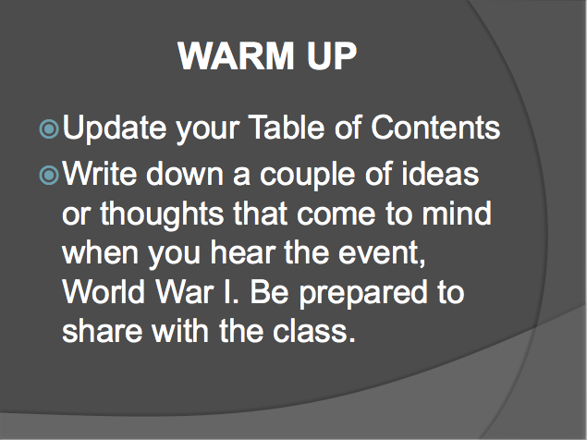

- World War I YouTube Video Clip
  - Introduction To Lesson On World War I (https://www.youtube.com/watch?v=8UcvJi8klz8)

- “What Caused World War I?” PowerPoint (Slides 1-14) (The American Journey, Goldfield)

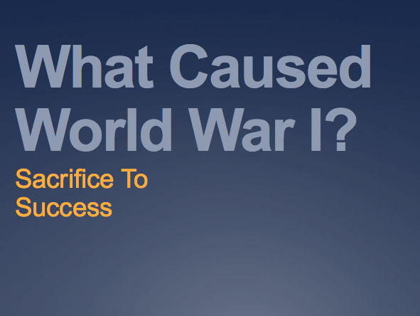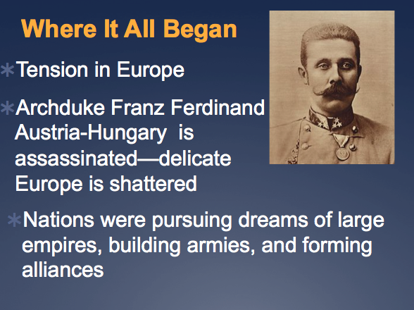

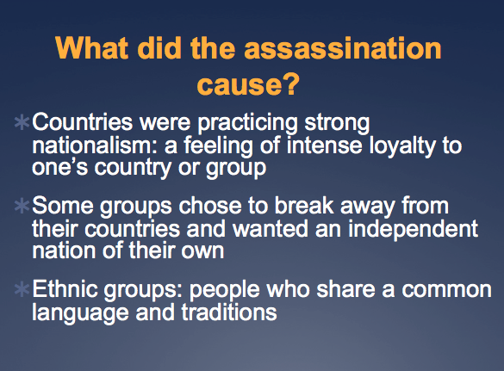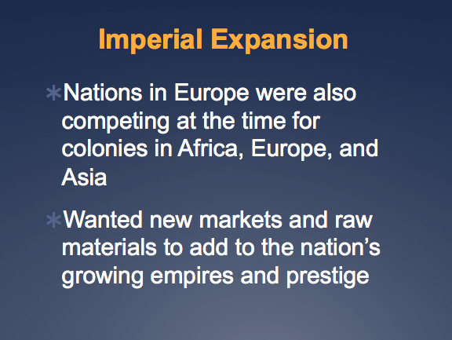

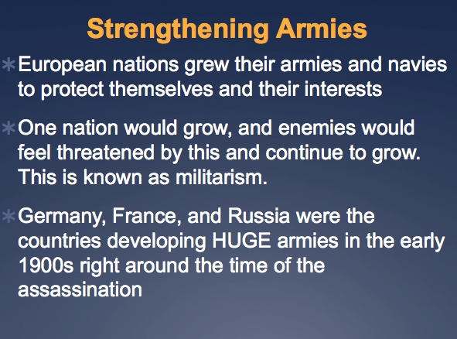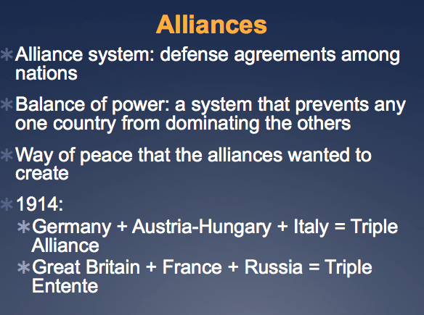

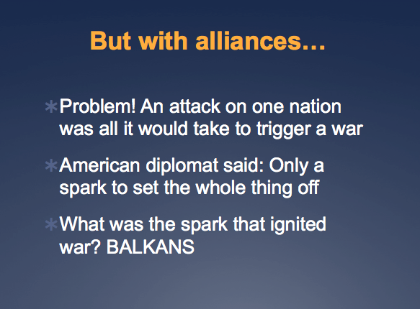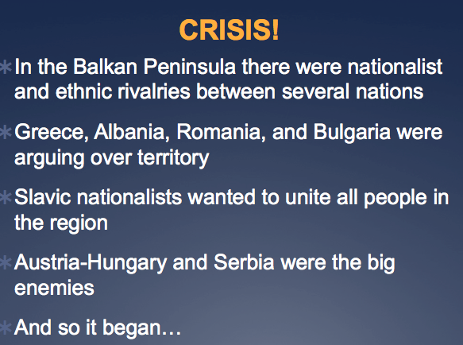

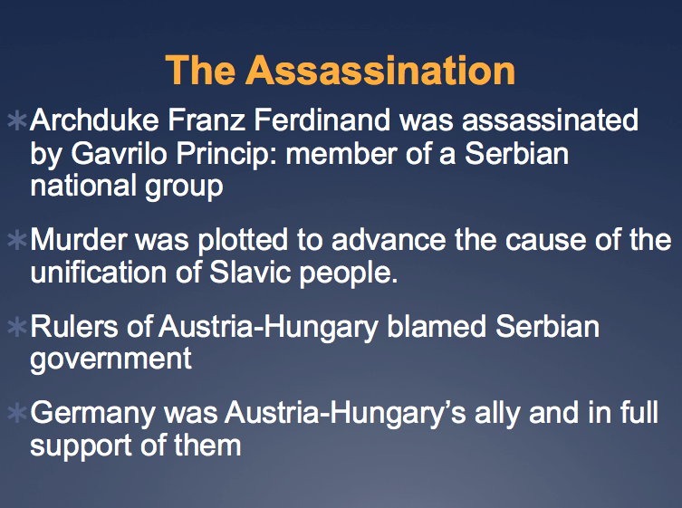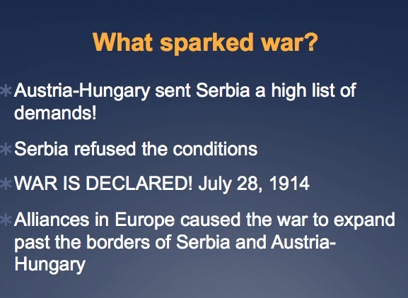

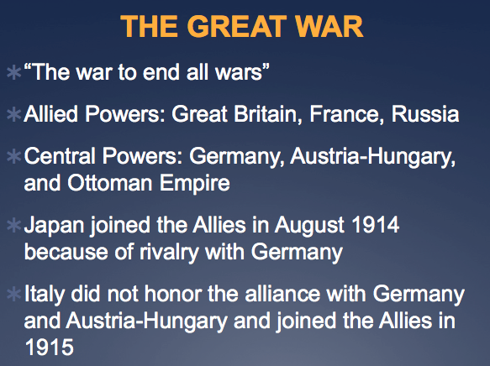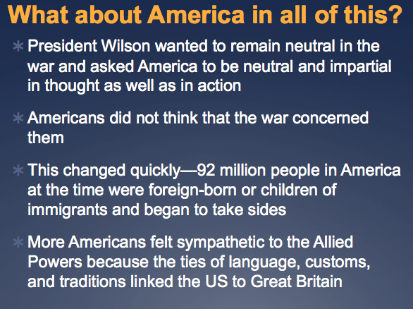

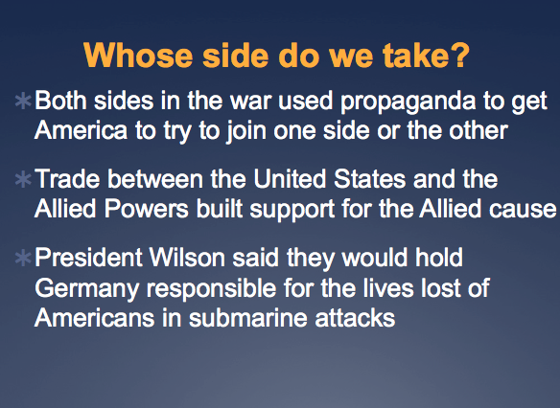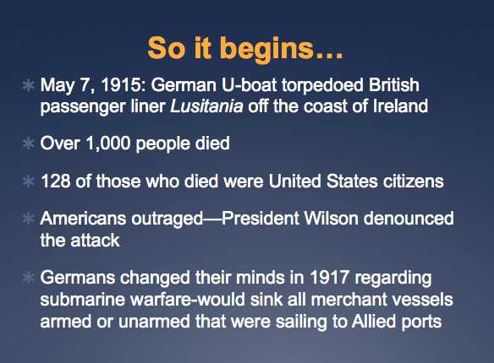

- “What Caused World War I?” Guided Notes (The American Journey, Goldfield)

Name________________________________Core: _________Date: ___________ TOC# _____
What Caused World War I?
Where It All Began
- Tension in Europe
- Archduke Franz Ferdinand assassinated—delicate Europe is shattered
- Nations were pursuing
  - ___________
  - ___________
  - ___________
- Additional Notes:

What Did The Assassination Cause?
- __________________: a feeling of intense loyalty to one’s country or group
- Countries were practicing a strong sense of this
- Some groups chose to break away from their countries and wanted an independent nation of their own
- ___________________: people who share a common language and traditions
- Additional Notes:

Imperial Expansion
- Nations in Europe were also competing at the time for colonies in _________, ____________, and __________.
- Wanted new markets and raw materials to add to the nation’s growing empires and prestige
- Additional Notes:

Strengthening Armies
- European nations grew their armies and navies to protect themselves and their interests
- _________________: when one nation grows, and enemies feel threatened by this and continue to grow
- _______________, ______________, and ____________ were the countries developing HUGE armies in the early 1900s right around the time of the assassination
- Additional Notes:

Alliances
- _____________ ______________: defense agreements among nations
- _____________ ____ __________: a system that prevents any one country from dominating others. This was a way of peace that the alliances wanted to create
- 1914:
  - ____________ + _____________________ + _________ = Triple Alliance
  - _________________ + ______________ + ___________ = Triple Entente
- Additional Notes:

But with Alliances…
- Problem! An attack on one nation was all it would take to trigger a war
- American diplomat said: only a _________ to set the whole thing off
- What was the spark that ignited war? ________________
- Additional Notes:

CRISIS!
- In the Balkan Peninsula there were nationalist and ethnic rivalries between several nations
- Greece, Albania, Romania, and Bulgaria were arguing over ____________
- Slavic nationalists wanted to unite all people in the region
- ______________________ and ___________ were the big enemies
- Additional Notes:

The Assassination
- Archduke Franz Ferdinand was assassinated by Gavrilo Princip: member of a ____________ national group
- Murder was plotted to advance _______________ of Slavic people
- Rulers of Austria-Hungary blamed Serbian government
- Germany was Austria-Hungary’s ________ and in full support of them
- Additional Notes:

What Sparked War?
- Austria-Hungary sent Serbia a high list of demands
- Serbia refused the conditions
- War is declared! ______________________
- Alliances in Europe caused the war to expand past Serbia and Austria-Hungary
- Additional Notes:

THE GREAT WAR
- “__________________________________”
- Allied Powers: _________________, ___________, ______________
- Central Powers: ________________, ___________________, ___________________
- Japan joined the Allies August 1914 due to rivalry with Germany
- Italy did not honor the alliance with Germany and joined allies in 1915
- Additional Notes:

What About America in all of this?
- President Wilson wanted to remain ___________ in the war and asked America to be neutral and impartial in thought and in action
- Americans did not think the war concerned them
- Changed quickly: ____ million people in America at the time were _____________________ or children of immigrants and began to take sides
- More Americans felt sympathetic to Allies because of Great Britain
- Additional Notes:

Whose Side Do We Take?
- Both sides in the war used _____________ to get America to try to join one side or the other
- Trade between the United States and the Allied Powers built support for the Allied cause
- President Wilson said they would hold Germany responsible for the lives lots of Americans in _________________ attacks.
- Additional Notes:

So It Begins:
- May 7, 1915: German U-Boat torpedoed British passenger liner _______________ off the coast of Ireland
- Over 1,000 people died, ______ of them were United States citizens
- Americans outraged---President Wilson denounced the attack
- Germans changed minds in 1917 and said they would sink all armed and unarmed merchant vessels sailing into Allied ports
- Additional Notes:

The Zimmerman Telegram
- Arthur Zimmermann, a __________ foreign minister sent a telegram to ___________ with an offer to the Mexican government
- Newspapers published the Zimmermann Telegram and Americans reacted angrily
- President Wilson knew the United States could no longer stay neutral in this war
- Additional Notes:

War!
- April 2, 1917
- President Wilson stands before a special session of Congress and declares war on ______________.
- Selection Service Act: fast way to establish a military draft
- Men aged _____-_____ registered by the millions (over _____ million signed up. ______ million were called to serve.
- Women did noncombat serving as:
  - __________ ______________
  - __________
  - __________
- Additional Notes:

Lesson Plan Day Two:

What Happens Next?

Context: This lesson will help students to further learn about the United States’ involvement in World War I and the Zimmermann Telegram. Students will work in groups to analyze the telegram and even have creativity to come up with their own code. Students will be able to relate a historical event and turn it into a real life note in their own life. It is important for students to see the connection between the Zimmermann Telegram and the United States involvement in the war. It is crucial for students to be able to take a historical moment in time and be able to relate it in some way to their own lives.

Plan Number: 2/15

Specific Learning Objectives:
SWBAT:
[Cog] GO SO
1. Analyze information from different sources
1.1 Identify how primary sources relate to a historic event
1.2 Apply information found in a primary source

[Aff] GO SO
4. Collaboratively work in groups
4.1 Share perspective with others
4.2 Participate in group work and discussion

[Perf] GO SO
8. Compose in various forms of assignments/activities
8.1 Compute own telegrams
8.2 Retell about a historic document

[CCSS]
CCSS.ELA-Literacy.RH.6-8.2 Determine the central ideas or information of a primary of secondary source; provide an accurate summary of the source distinct from prior knowledge of opinions.
CCSS.ELA-Literacy.RH.6-8.9 Analyze the relationship between a primary and secondary source on the same topic.

Materials/Technology Resources Required:
- Computer/Projector
- “What Caused WWI?” PowerPoint (Slides 13-16)
- “What Caused WWI?” Guided Notes (end)
- Zimmermann Telegram Primary Document
- Zimmermann Telegram Group Activity
- Create Your Own Telegram Instructions
- Pencil/Pen
Time: 50 minutes
Instructional Procedures/Steps:
- Warm Up (5 minutes)
- Students will come into class and update their Table of Contents and write their homework assignment into their agenda. (2 minutes)
- Projected onto the board will be the warm-up, “What would you do if you were in President Wilson’s shoes? Would you declare war and involve the United States or stay out of it? Explain.” (3 minutes)
- Bridge (5 minutes)
- Discuss with students what their responses were to the warm up. What would they have done if they were President Wilson and had to make a decision that would change the future of the United States? (4 minutes)
- Listen to student responses and discuss different viewpoints that certain students have. Possibly even give your own opinion to share with students. (1 minute)
- Instruction – How did it happen? (10 minutes)
- Give a description and have students fill in the end of their guided notes about how President Wilson entered the United States into World War I. (7 minutes)
- Explain to students what the Zimmermann Telegram was and what this meant to certain countries. (3 minutes)
- Activity (25 minutes)
- Give each group a copy of the Zimmermann Telegram primary documents to answer questions and analyze. (2 minutes)
- Students will go through the questions as a group and give their responses. Groups will work with assignments. The group leader will be the one prompting and asking the questions. The two researchers of the group will look for answers and understand the documents. The last group member will be the recorder, writing down the group’s responses. (10 minutes)
- Walk around as students are working in groups, listening for what their answers are to the critical thinking questions.
- Explain to students that they will turn in their activity sheet and I will make copies for each group to place in their Table of Contents.
- After answering the small list of questions, explain to students that they will make their own code and come up with a telegram to send to a friend. This will be turned in tomorrow at the beginning of class and will be homework if they do not finish in class today. (12 minutes)
- Wrap Up (5 minutes)
- Bring students back together and have them pay attention for last minute announcements. (2 minutes)
- Have students finish their telegram codes and to name them their last name, code. For example, “Scruggs Code”. Tell students that they are to finish for homework and turn in at the beginning of class. (2 minutes)
- Students will turn in their group activity sheets for an activity completion grade as they exit class. (1 minute)

Evaluation: I will know if my students understood the material being taught by walking around during group work to make sure that students are staying on task and by the activity sheet they will turn in at the end of class. I also will see if they understood by looking at their own code that they created after reading the Zimmermann Telegram.

Accommodations: My students with IEP/504 will not need any accommodations for this lesson.

Appendix of Materials Needed:

- Warm Up (displayed on the projector)
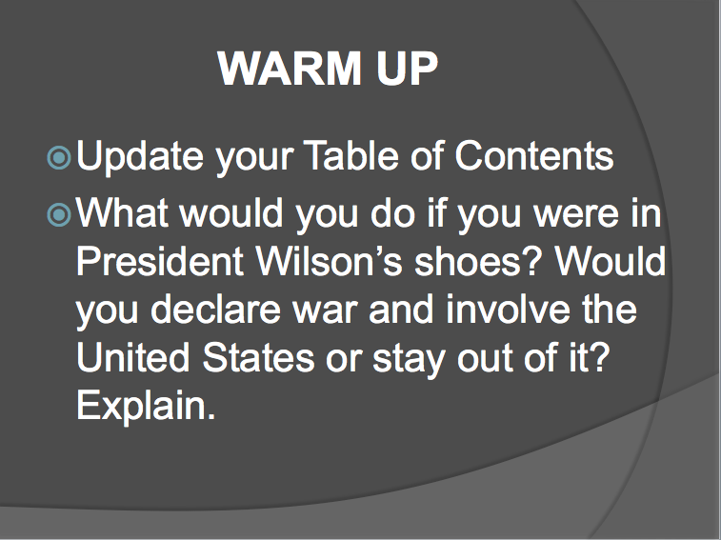

- What Caused WWI PowerPoint (Slides 13-16) (The American Journey, Goldfield)

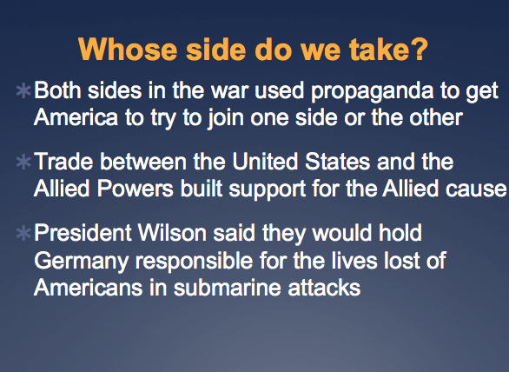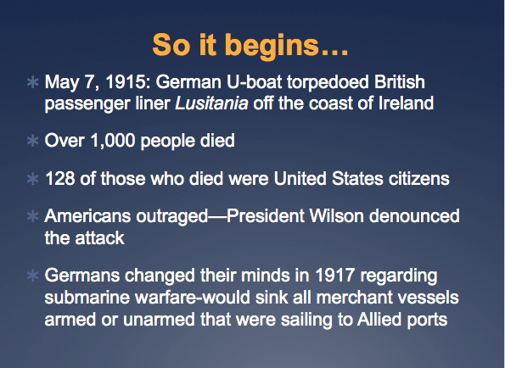

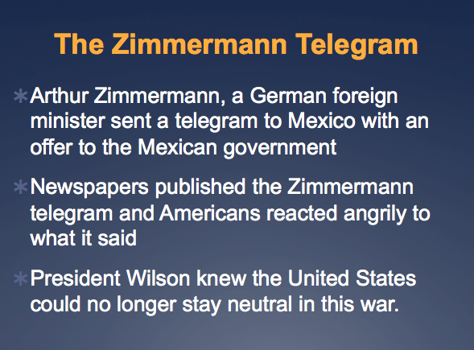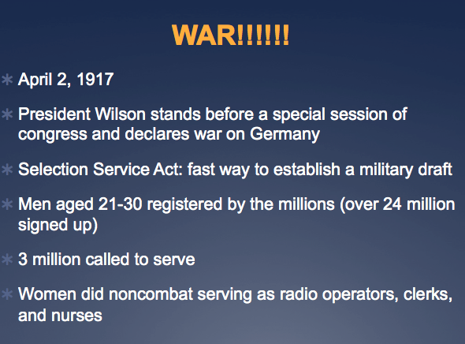

- Zimmermann Telegram Primary Document (The Zimmermann Telegram, http://www.archives.gov/education/lessons/zimmermann/#documents)

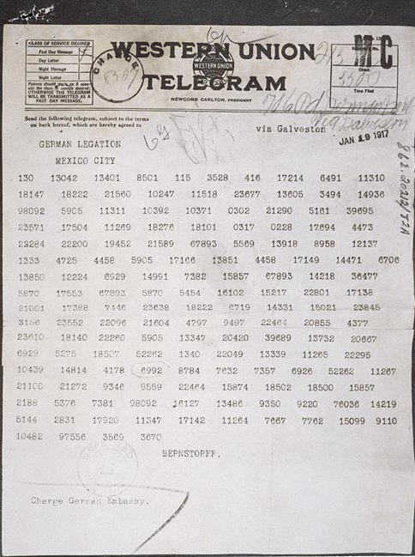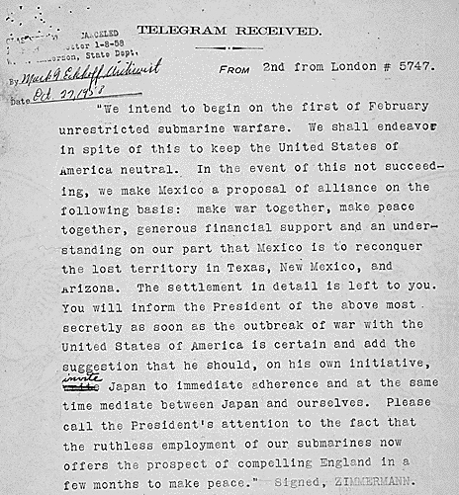

- Zimmermann Telegram Group Activity

Name________________________________Core: _________Date: ___________ TOC# _____
Zimmermann Telegram Group Activity
Answer the following questions as a group, working collaboratively to figure out how this telegram relates to the larger picture of World War I beginning. Each group member should be assigned a task. The group leader will lead a discussion about the questions and turn in the activity. The group recorder will write down the answers. The group researchers will analyze the documents to spark responses (there can be more than one researcher).

- What type of source is the Zimmermann Telegram? (primary, secondary, etc.)

- What does the document look like? What do you think telegrams did during the early 1900s for communication?

- If you saw a bunch of numbers on a document like the Zimmermann Telegram, would you find this suspicious, thinking it might mean something else?

- What do the numbers mean?

- How do the numbers correspond to the letters in the received message?

- Did this threat give the United States the wrong message, or just the one they needed to involve themselves in war?

- Think of a way that you would send a message to a friend that you did not want anyone else to understand. How would you go about doing this? How does this relate to the Zimmermann Telegram?

- Create Your Own Telegram Instructions

Create Your Own Telegram!
You’ve seen and exhibited the Zimmermann Telegram that sparked the start of World War I. Now it’s your turn! Create your own telegram as if you were writing a short note to your friend. Create a key to break the code with your note, or what the note actually is saying for someone to try to break your code. Your code can consist of letters, numbers, or symbols—however you see fit! This will count as a classwork/homework grade, so do your best! If you do not finish in class, finish this assignment up for homework. This assignment is due at the beginning of class tomorrow. Be sure to label or call your code, LAST NAME Code. Example: Scruggs Code. Good luck!

Lesson Plan Day Three:

Where Do We Go From Here?

Context: In this lesson, students will be learning where the United States went from the minute they were involved in World War I. Students will grasp an understanding of propaganda and how it was used as a recruiting tactic for the United States and other countries. Students will learn how propaganda can be used today and will be able to create their own posters to recruit for World War I. It is important for students to see how the United States created an army to fight for the war when it was not our intention to join the war at all. Students also will audibly hear a song to help them to remember this time of recruitment for war.

Plan Number: 3/15

Specific Learning Objectives:
SWBAT:
[Cog] GO SO
- Identify sacrifice and success in unit and students’ own lives
  - Understand techniques in historic time period
  - Recognize own perspective

[Aff] GO SO
4. Participate effectively
4.1 Fulfill individual role
4.2 Make choices as a group

[Perf] GO SO
7. Present material through different mediums
7.1 Create posters of propaganda
7.2 Share original piece with the class

[CCSS]
CCSS.ELA-Literacy.RH.6-8.4 Determine the meaning of words and phrases as they are used in a text, including vocabulary specific to domains related to history/social studies.
CCSS.ELA-Literacy.RH.6-8.7 Integrate visual information (e.g., in charts, graphs, photographs, videos, or maps) with other information in print and digital texts.

Materials/Technology Resources Required:
- Computer/Projector
- “Over There” YouTube Video by George Cohan
- “Over There” lyrics sheet
- Propaganda Pictures for WWI
- Posters
- Crayons/Markers/Colored Pencils
Time: 50 minutes

Instructional Procedures/Steps:
- Warm Up (5 minutes)
- Students will come into class and update their Table of Contents and turn in their codes they created for homework to their select period bin. At this time, I will handout copies of the Zimmermann Telegram Group Activity for each student to have from their group’s notes to study for the test. (2 minutes)
- Warm Up (projected on the front board): “If you had something that you were trying to recruit people for (a club, sports team, etc.), how would you go about trying to get individuals to sign up? Give a few examples and explain.” (3 minutes)
- Bridge (3 minutes)
- Go over the warm up and ask students what their answers would have been. Then ask them the larger picture about what they would do if they were recruiting soldiers for war. These soldiers may not have had any prior experience or any training to go war. How would you get them to join? (3 minutes)
- Instruction/Group Activity (27 minutes)
- Explain to students what propaganda is and how this correlated with ways that the United States had to get individuals to sign up for the war effort. Show a few examples of WWI propaganda. (3 minutes)
- Tell students how many people President Wilson had to draft to go overseas, and include how many North Carolinians went overseas. Over 4 million were drafted to go fight. (3 minutes)
- Students will complete a group activity, each being assigned to come up with their own poster of propaganda to recruit for the war. (15 minutes)
- Posters students complete will be displayed around the room during the Sacrifice to Success unit.
- Have groups share their posters and explanation of what they put on their poster and why they put certain things on it. (6 minutes)
- Pulling It All Together (15 minutes)
- Have groups turn in their posters. This will count as a class work grade. (2 minutes)
- Explain that posters were not the only way to get citizens involved in the war. Music was another way, and “Over There” by George Cohan was a popular song that they played at the time to get people involved. Hand out lyrics sheet to “Over There” by George Cohan for students to refer to. (3 minutes)
- Play “Over There” YouTube video to the class for them to hear before class ends, explaining the next step was warfare and we will discuss it in class tomorrow. (10 minutes)

Evaluation: I will formally evaluate students on if they understood the material about propaganda or not based on the information provided in their posters that they create with their groups. I will informally assess my students by walking around and making sure that they are working collaboratively and participating in the group activity.

Accommodations: My students with IEP/504 will not need any accommodations for this lesson.

Appendix of Materials Needed:

- Warm Up (displayed on the projector)
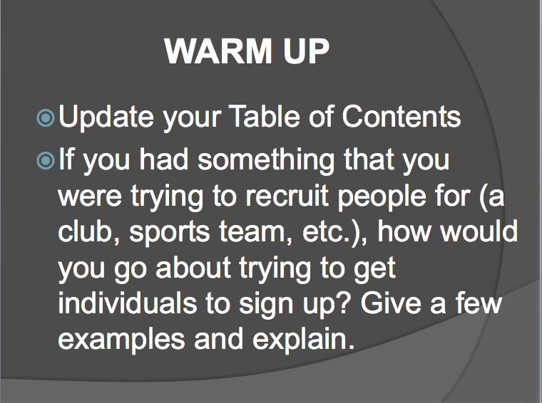

- “Over There” YouTube Video by George Cohan
  - Over There (https://www.youtube.com/watch?v=B6hRDS3LvQQ)

- “Over There” by George Cohan lyrics (image from Chronicle of America, Anderson, et. al.)
“Over There” Song Lyrics
By: George Cohan
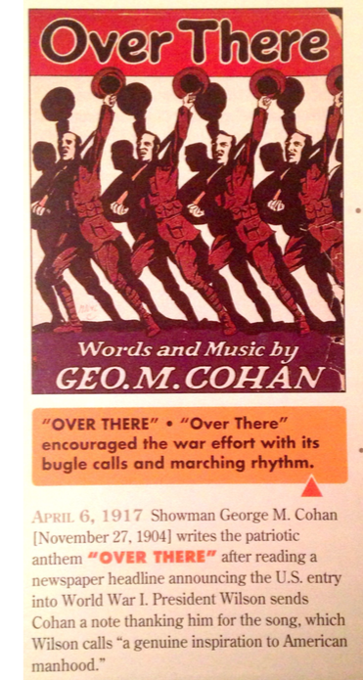
Johnnie, get your gun,
Get your gun, get your gun,
Take it on the run,
On the run, on the run.
Hear them calling, you and me,
Every son of liberty.
Hurry right away,
No delay, go today,
Make your daddy glad
To have had such a lad.
Tell your sweetheart not to pine,
To be proud her boy's in line.

Over there, over there,
Send the word, send the word over there -
That the Yanks are coming,
The Yanks are coming,
The drums rum-tumming
Everywhere.
So prepare, say a prayer,
Send the word, send the word to beware.
We'll be over, we're coming over,
And we won't come back till it's over
Over there.

Johnnie, get your gun,
Get your gun, get your gun,
Johnnie show the Hun
Who's a son of a gun.
Hoist the flag and let her fly,
Yankee Doodle do or die.
Pack your little kit,
Show your grit, do your bit.
Yankee to the ranks,
From the towns and the tanks.
Make your mother proud of you,
And the old Red, White and Blue.

Over there, over there,
Send the word, send the word over there -
That the Yanks are coming,
The Yanks are coming,
The drums rum-tumming
Everywhere.
So prepare, say a prayer,
Send the word, send the word to beware.
We'll be over, we're coming over,
And we won't come back till it's over
Over there.

- Propaganda Pictures for WWI Examples (Chronicle of America, Anderson, et. al.)
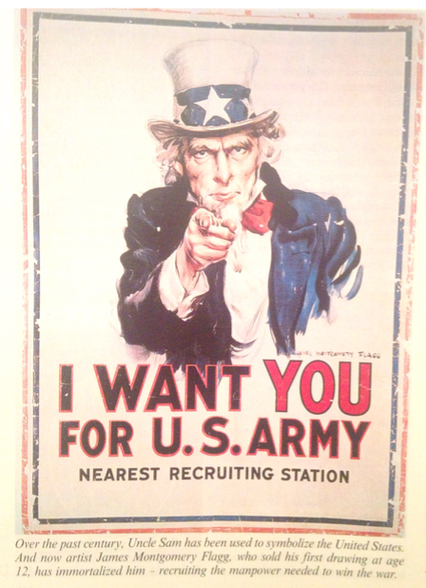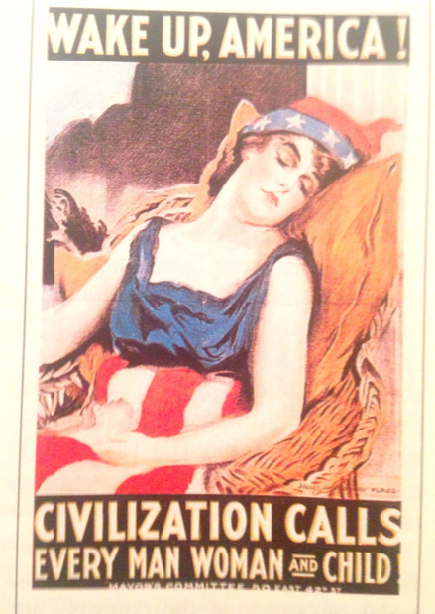
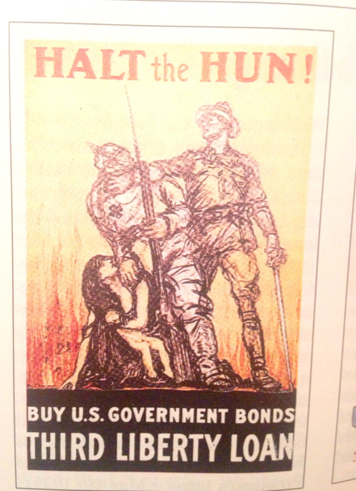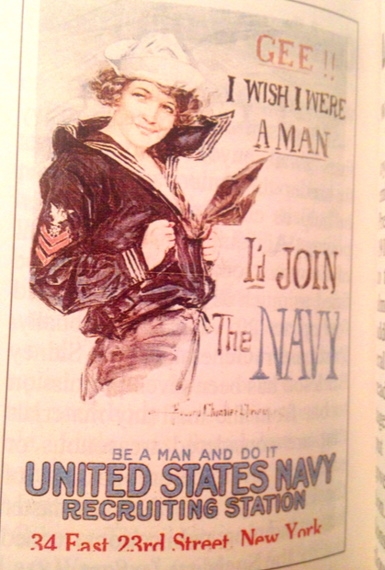

Lesson Plan Day Four:

World War I Warfare

Context: In this lesson, World War I warfare will be learned through students teaching. They will teach each other about the different types of warfare that were new to fighting and how the United States and other countries used these. It is important for students to see the new warfare that developed because of World War I and how this changed the game for wars in the future as far as warfare is concerned.

Plan Number: 4/15

Specific Learning Objectives:
SWBAT:
[Cog] GO SO
1. Analyze information from different sources
1.1 Comprehend information learned
1.2 Investigate warfare and effect on the war

[Aff] GO SO
6. Collaboratively work in groups
6.1 Participate in group activity
6.2 Fulfill individual role
6.3 Share information with others

[Perf] GO SO
8. Compose in various forms of assignments/activities
8.1 Contribute written work
8.2 Utilizes information of others

[CCSS]
CCSS.ELA-Literacy.RH.6-8.2 Determine the central ideas or information of a primary of secondary source; provide an accurate summary of the source distinct from prior knowledge of opinions.
CCSS.ELA-Literacy.RH.6-8.8 Distinguish among fact, opinion, and reasoned judgment in a text.

Materials/Technology Resources Required:
- Computer/Projector
- “Over There” YouTube Video by George Cohan
- World War I Warfare Jigsaw Activity Sheet
- Warfare Handouts (different type of warfare given to each group)
- Sacrifice To Success Unit Project Instructions/Rubric

Time: 50 minutes

Instructional Procedures/Steps:
- Warm Up (5 minutes)
- Students will come into class and update their Table of Contents. The song “Over There” will be playing during the warm up and as students walk in to refresh memories about what we talked about the previous day. (3 minutes)
- Warm Up: “What do you predict were some of the weapons that were used in World War I that had not been used before?” (2 minutes)
- Activity (25 minutes)
- Explain to students that they will complete a Jigsaw Activity to learn in depth about different types of warfare that were used in World War I. (5 minutes)
- Each group will be given a specific type of warfare. They will use the resource sheets provided to learn about warfare (World War I Weaponry). Once the groups have become knowledgeable of the topic, they will move to another group and share with each other what they learned about different weapons. They will fill in their guided sheets about warfare to keep for their notes. (15 minutes)
- Have students go back to their groups and share what they learned and prompt class discussion about weapons during war. (15 minutes)
- Instruction (10 minutes)
- Explain to students their “Sacrifice to Success” unit project instructions. Pass out the handout explaining the project as well as the rubric attached so they can see how they will be graded on the assignment. Explain that this project gives them many options and they will be given some time in class to either work on the project or as any questions that they may have.
- Explain to students that they can begin the project but may want to research a topic that we have not yet covered until towards the end of the unit. If they want to do some prior research, they are more than welcome to do so.
- Wrap Up (10 minutes)
- Explain to students that they should be holding onto their notes sheets and activity sheets to reference to study for their World War I quiz that will be given next week to culminate this portion of the unit. (2 minutes)
- Remind students to be thinking about a time in their lives when they had to sacrifice something and that they will use this for their final sacrifice unit project due in a couple of weeks. (3 minutes)
- For homework, have students be thinking and brainstorming about what was happening to the soldiers during the war overseas. They should bring in a list of three ideas that they believe were going through a soldier’s mind to share in the warm up for class tomorrow. (5 minutes)

Evaluation: I will informally assess students by seeing if they understood the material they were reading about warfare with their groups when they become knowledgeable of the warfare and how able they are to share the information that they learned with their group members. I also will assess

Accommodations: The accommodations for this unit include highlighted warfare handouts for students with low reading levels.

Appendix of Materials Needed:
- Warm Up (displayed on the projector)
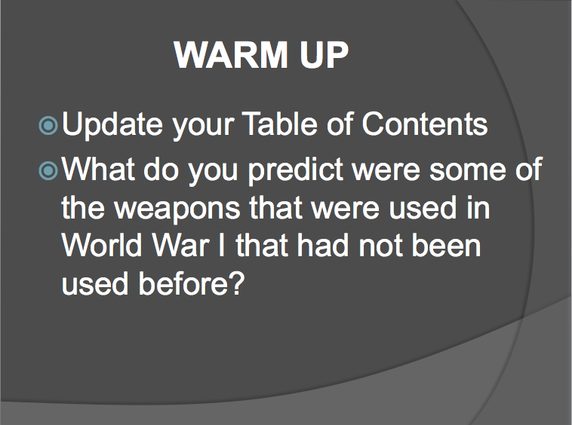
- “Over There” YouTube Video by George Cohan
  - Over There (https://www.youtube.com/watch?v=B6hRDS3LvQQ)

- World War I Warfare Jigsaw Activity Sheet

Name________________________________Core: _________Date: ___________ TOC# _____
World War I Warfare
Jigsaw Activity

Each original group member will receive a copy of this sheet. You will each be given a different type of warfare. You will sit with everyone else who has the same type of warfare you were given. You will learn about the warfare from the handout provided at your new group table and answer the following questions. Then, report back to your original group and report about your World War I warfare for everyone else to learn about and fill in the information below.

Bayonets:
- What is it?

- How is the warfare used/how does it work?

- Advantages/Disadvantages:

- Could you protect yourself from it? If not, how could you use it?

Flamethrowers:
- What is it?

- How is the warfare used/how does it work?

- Advantages/Disadvantages:

- Could you protect yourself from it? If not, how could you use it?

Trench Mortars:
- What is it?

- How is the warfare used/how does it work?

- Advantages/Disadvantages:

- Could you protect yourself from it? If not, how could you use it?

Grenades:
- What is it?

- How is the warfare used/how does it work?

- Advantages/Disadvantages:

- Could you protect yourself from it? If not, how could you use it?

Machine Guns:
- What is it?

- How is the warfare used/how does it work?

- Advantages/Disadvantages:

- Could you protect yourself from it? If not, how could you use it?

Poison Gas:
- What is it?

- How is the warfare used/how does it work?

- Advantages/Disadvantages:

- Could you protect yourself from it? If not, how could you use it?

- Warfare Handouts (different type of warfare given to each group) (Weapons of War-Introduction, http://www.firstworldwar.com/weaponry/index.htm)

Name________________________________Core: _________Date: ___________ TOC# _____

World War I Warfare: Bayonets
According to tradition the bayonet was developed in Bayonne, France, in the early 17th century. That it was still apparently in commonplace use during the First World War may seem incongruous when compared to leaps in technological warfare typified by artillery, grenades and poison gases. Nevertheless all sides from 1914-18 used the bayonet, even if its use was more psychological than practical.

Used to Stoke the Fire
Veterans of the Great War, when interviewed, tended to play down the impact of the bayonet during the war. Many remarked (partly in jest) that the bayonet was used primarily as a splendid means of toasting bread, and for opening cans, to scrape mud off uniforms, poking a trench brazier or even to assist in the preparation of communal latrines.

Simple Design
The German army developed more types of bayonet than all other armies combined. They produced special adaptors so that captured enemy bayonets could be fitted to the common Gewehr 98 rifle.
In essence a bayonet is simply a simply a blade that is attached to the barrel of a rifle for use in close combat.
Most bayonets were of simple design, of the knife variety, although variations existed. For example the French devised a needle blade for use on Lebel rifles. Notoriously, the German army produced a 'saw-back' blade that, as its name suggests, gave the appearance of a saw with its double row of teeth on the back edge.
Produced chiefly for use by engineering units for specific tasks, the saw-back blade proved a blessing for Allied propaganda purposes. Keen to represent the Germans as ruthless, bloodthirsty 'Huns', the popular press widely propagated the notion that this type of bayonet had been specifically developed as a refinement of German brutality for use in close combat.
Although it could doubtless be put to such use, it was actually designed to be used as a saw when the need arose.

Personified the Offensive Spirit
In many ways the bayonet was a throwback to the concept of an aggressive method of warfare.
Used traditionally by the colonial powers such as France and Britain in combat against far less well-armed adversaries, it was deemed a positive example of a co-called 'offensive spirit'.
Given that the French pre-war blueprint for war, Plan XVII, required an abundance of offensive spirit from the French army in their planned conquest of Alsace and Lorraine, the bayonet must have seemed an ideal weapon for the coming war.
In reality however it transpired that technological advances in defensive warfare had outstripped those of offensive warfare. The machine gun held sway over the battlefield. Infantry advancing with bayonets affixed to rifles were invariably mown down before they reached enemy trenches. The opportunity to use the bayonet was thus much restricted.
Even when a raiding party had reached the enemy position the role of the bayonet was often primarily one of guarding the grenadiers among their party, whose task was to race down the trench lobbing hand grenades into dugouts as they passed. Indeed, bombing parties invariably contained at least two 'bayonet men' whose job was solely to defend the bombers.
One advantage of using a bayonet in close crowded combat, as opposed to a rifle or handgun, was its avoidance of risk in injuring one's fellow soldiers. A bullet fired at close range into an enemy could well pass through his body and enter a friend standing (or fighting) behind him.

Close Combat Fighting
Of course there were still many occasions when close combat fighting was necessary.
This was the ideal scenario for the use of the bayonet. Nevertheless, while it was seldom actually used, experienced soldiers generally preferring other methods, carrying improvised clubs, blades or knuckledusters.
Curiously the official British bayonet-training manual gave poor advice regarding the bayonet's usage. Soldiers were instructed to direct the bayonet at the vulnerable points of the enemy's body: the throat, left or right breast and left or right groin.
Aiming the bayonet blade at the breast ran the risk of driving into the breastbone, making removal of the blade highly problematic. Similarly, aiming the blade at the groin inevitably resulted in excruciating pain to the victim, such that they would often grab the bayonet in an attempt to pull the blade out. In such cases soldiers often had to remove the blade from the rifle simply in order to continue with the attack.
There was undeniably psychological value to the infantry in carrying a bayonet, even if in practice it was seldom used. Bayonets continued to be commonly issued in the Second World War.

World War I Warfare: Flamethrowers
The flamethrower, which brought terror to French and British soldiers when used by the German army in the early phases of the First World War in 1914 and 1915 (and which was quickly adopted by both) was by no means a particularly innovative weapon.

The basic idea of a flamethrower is to spread fire by launching burning fuel. The earliest flamethrowers date as far back as the 5th century B.C. These took the form of lengthy tubes filled with burning solids (such as coal or sulfur), and which were used in the same way as blow-guns: by blowing into one end of the tube the solid material inside would be propelled towards the operator's enemies.

The flamethrower was inevitably refined over the intervening centuries, although the models seen in the early days of World War One were developed at the turn of the 20th century. The German army tested two models of flamethrower - or Flammenwerfer in German - in the early 1900s, one large and one small, both developed by Richard Fiedler.
The smaller, lighter Flammenwerfer (the Kleinflammenwerfer) was designed for portable use, carried by a single man. Using pressurised air and carbon dioxide or nitrogen it belched forth a stream of burning oil for as much as 18 meters.
Fielder's second, larger model (the Grossflammenwerfer), worked along the same lines but was not suitable for transport by a single person, but whose maximum range was twice that of the smaller model; it could also sustain flames for a (then) impressive forty seconds, although it was decidedly expensive in its use of fuel.

Having tested the Flammenwerfer in 1900 the German army deployed it for use in three specialist battalions from 1911 onwards. It was put to initial wartime use against the French in the southeastern sector of the Western Front from October 1914, although its use was sporadic and went largely unreported.

The first notable use of the Flammenwerfer came in a surprise attack launched by the Germans upon the British at Hooge in Flanders. Springing forward at 0315 on 30 July 1915 the Germans made effective use of the portable Flammenwerfer, with gas cylinders strapped to the back of the men responsible for using the instrument, a lit nozzle attached to each cylinder.

The effect of the dangerous nature of the surprise attack proved terrifying to the British opposition, although their line, initially pushed back, was stabilized later the same night. In two days of severe fighting the British lost 31 officers and 751 other ranks during the attack.

They were undeniably useful when used at short-range, but were of limited wider effectiveness, especially once the British and French had overcome their initial alarm at their use. The operators of Flammenwerfer equipment also lived a most dangerous existence.

Quite aside from the worries of handling the device - it was entirely feasible that the cylinder carrying the fuel might unexpectedly explode - they were marked men; the British and French poured rifle-fire into the area of attack where Flammenwerfers were used, and their operators could expect no mercy should they be taken prisoner. Their life expectancy was therefore short.

By the close of the war flamethrower use had been extended to use on tanks, a policy carried forward to World War Two. Flame-throwing equipment, albeit somewhat refined, continues in use to the present day.

World War I Warfare: Trench Mortars
The Mortar: A Definition
A mortar is essentially a short, stumpy tube designed to fire a projectile at a steep angle (by definition higher than 45 degrees) so that it falls straight down on the enemy.
From this simple description it will be immediately apparent that the mortar was ideally suited for trench warfare, hence the common application of the 'trench' prefix.

Mortar Advantages Over Artillery
The chief advantage of the mortar was that it could be fired from the (relative) safety of the trench, avoiding exposure of the mortar crews to the enemy. Furthermore, it was notably lighter and more mobile than other, larger artillery pieces. And, of course, the very fact that the mortar bomb fell almost straight down meant that it would (with luck) land smack in the enemy trench.
Just as the mortar was another example of an ancient weapon given fresh reign, so too it was predictable that the German army, so better prepared for war than any of its counterparts in 1914, should have spotted the enormous potential of the mortar some years ahead of the Great War.

The State of Mortar Readiness in 1914
Indeed, German military observers of the Russo-Japanese War of 1904-05 not only came away with a new respect for hand grenades, but with fresh ideas for the use of the mortar bomb they had seen deployed.
In fairness to the Allied powers the Germans had a specific use for the mortar when they began to stockpile it in the immediate pre-war years. In short, they envisaged its use against France's eastern fortresses. Consequently by the time war arrived in August 1914 the Germans had some 150 mortars available.
And what of the French themselves? The re-birth of the mortar caught the French army entirely by surprise, as it did the British. At least the French could scramble to put into use ancient century-old Napoleonic mortars (referred to by the British as Toby mortars in honor of the British officer who had been struck with the idea of securing such old stockpiles of the weapon from the French).
The British however were entirely without supplies of the mortar, it having not been used at all during the South African War of 1899-1902. Even once the Germans had demonstrated its merits there were elements within the British high command that argued that it was without much worth. It took David Lloyd George (Prime Minister from late 1915) to push through manufacture of the weapon for it to be taken seriously.
However, as with the grenade, once the British finally grasped the manifest merits
of the mortar it was embraced wholeheartedly, and its design much improved upon. Just as the British Mills bomb became the war's most famous hand grenade, so the Stokes bomb became the best-known mortar.

Mortar Tactics
Mortars were undeniably effective in terms of trench warfare. Soldiers would often strain their ears to catch the "plop!" sound that indicated the firing of an enemy mortar, and consequently hasten into cover.
Inevitably, mortar positions rapidly came under fire from enemy artillery once their presence was detected. For this reason they were unpopular when sited among a given group of infantrymen, for it almost guaranteed a busy time along the trench.
Mortars were variously used to take out enemy machine gun posts, suspected sniper posts or other designated features. Larger mortars were occasionally used to cut enemy barbed wire, generally in situations were field artillery could not be used.

World War I Warfare: Grenades
As with numerous weapons significantly developed upon during World War One, the use of grenades (whose name probably dates from the French word for pomegranate) dated back some hundreds of years - to the fifteenth century in fact.

Grenade Supplies in 1914
Regarded as practical for siege operations only since Napoleonic times however, the grenade came to the attention of German army planners (notable among others) during the Russo-Japanese War of 1904-05.
As with most things at the start of the war in August 1914, the Germans were ahead of the pack in terms of grenade development. Even as war began the Germans had 70,000 hand grenades in readiness, along with a further 106,000 rifle grenades.
Curiously, when many, perhaps most, people are asked to consider the means of trench attack most popular during the First World War, the rifle or bayonet is often suggested as the most likely answer.

Two Forms of Detonation
Grenades - either hand or rifle driven - were detonated in one of two ways. They were either detonated on impact (percussion) or via a timed fuse.
Generally speaking, infantrymen preferred timed fuses (of whatever amount of time) to percussion devices, since there remained the constant risk of accidentally jolting a grenade while in a trench and setting off an explosion.
The idea of using a pin, extracted by hand from a grenade, to set off a timed fuse quickly became commonplace and was a feature of most later grenades. Another, earlier, method of igniting the fuse was via the so-called 'stick' grenade, where the fuse was lit when the grenade left the handle (stick) to which it was attached.
Yet striking the grenade like a match before it was promptly dispatched skywards ignited another type, cylindrical and referred to as the ‘cricket ball’ grenade.

Grenade Development
However grenade development soon took off and, at least on the Western Front, ad-hoc types dwindled in numbers as better models appeared.
Rifle grenades were simply attached to a rod and placed down the barrel of a rifle, or instead placed in a cup attached to the barrel, and were launched by the blast of a blank cartridge. Such grenades were never popular however, and were deemed (correctly) as inaccurate. The Germans ceased using rifle grenades in 1916, although they continued to experiment with revised models.
The British and French however persisted with cup grenades. The British, who had pioneered their use, together with the French improved the range of cup grenades from the average 180-200 meters to an impressive 400 meters (using fin grenades).
The Germans belatedly restarted using cup grenades in 1918.
The first truly popular British hand grenade - simply referred to as 'No. 15' - was churned out in huge numbers by the close of 1915, although its lack of performance in wet weather promptly led to a sharp downturn in its popularity. Whereas up to half a million No, 15's were produced in the autumn of 1915, they were seldom used at all beyond the turn of the year.

Greatest Grenade Battle of the War
Undoubtedly the greatest grenade battle of the war occurred on the Pozieres Heights on the night of 26-27 July 1916.
Lasting for twelve-and-a-half hours without a break the Australians, with British support, exchanged grenades with their German foes (who threw multiple types of grenade: sticks, cricket balls, egg bombs and rifle grenades). The allied contingent alone threw some 15,000 Mills bombs during the night.
Many grenadiers were killed that night, while many others simply fell down due to complete exhaustion.

World War One and Thereafter...
With the conclusion of World War One the grenade continued to hold its place firmly within the armory of every nation's army. During World War Two the US alone manufactured some 50 million fragmentation grenades.
Its development has continued to the present day.

World War I Warfare: Machine Guns
The machine gun, which so came to dominate and even to personify the battlefields of World War One, was a fairly primitive device when general war began in August 1914. Machine guns of all armies were largely of the heavy variety and decidedly ill-suited to portability for use by rapidly advancing infantry troops. Each weighed somewhere in the 30kg-60kg ranges - often without their mountings, carriages and supplies.

The Machine Gun in 1914
The 1914 machine gun, usually positioned on a flat tripod, would require a gun crew of four to six operators. In theory they could fire 400-600 small-caliber rounds per minute, a figure that was to more than double by the war's end, with rounds fed via a fabric belt or a metal strip.
The reality however was that these early machine guns would rapidly overheat and become inoperative without the aid of cooling mechanisms; they were consequently fired in short rather than sustained bursts. Cooling generally took one of two forms: water-cooled and, increasingly as the war developed, air-cooled. Water jackets would provided for the former (which held around one gallon of liquid) and air vents would be built into the machine gun for the latter.
Water cooled machine guns would still overheat relatively quickly (sometimes within two minutes), with the consequence that large supplies of water would need to be on hand in the heat of a battle - and, when these ran out, it was not unknown for a machine gun crew to solve the problem by urinating into the jacket.
Whether air or water cooled, machine guns still jammed frequently, especially in hot conditions or when used by inexperienced operators.
Consequently machine guns would often be grouped together to maintain a constant defensive position.
Estimates of their equivalent, accurate, rifle firepower varied, with some estimating a single machine gun to be worth as many as 60-100 rifles: a more consensual figure is around 80, still an impressively high figure.

The Machine Gun as an Offensive Weapon
Understandably most historical accounts of the First World War have tended to emphasize the defensive strengths of the machine gun. Throughout the war efforts were made to produce an infantry assault version, such as the Lewis Light Machine Gun, although these efforts were generally unsatisfactory.
Although lighter at around 12kg they were still considered too heavy and bulky for rapidly advancing infantry. Attempts to transport light machine guns by wheeled carriages or pack animals were ultimately unsuccessful: the infantry invariably outpaced such methods.
By 1918 however one-man portable machine guns (including the formidable Bergmann MP18 submachine gun) were put to some use (each weighing 9-14kg), although maintaining sufficient ammunition supplies remained a difficulty.
Although often not truly portable light machine guns were more readily transported on roads or flat ground by armored cars.
As the war developed machine guns were adapted for use on tanks on broken ground, particularly on the Western Front (where the majority of machine guns were deployed).
Light machine guns were adopted too for incorporation into aircraft from 1915 onwards, for example the Vickers, particularly with the German adoption of interrupter equipment, which enabled the pilot to fire the gun through the aircraft's propeller blades.
In response to the increasing success of machine guns mounted on aircraft it was perhaps inevitable that machine guns should similarly be developed as anti-aircraft devices (in France and Italy), sometimes mounted on vehicles. Similarly machine guns began to be added to warships as a useful addition to naval armaments.

World War I Warfare: Poison Gas
Considered uncivilized prior to World War One, the development and use of poison gas was necessitated by the requirement of wartime armies to find new ways of overcoming the stalemate of unexpected trench warfare.

Mustard Gas
Remaining consistently ahead in terms of gas warfare development, Germany unveiled an enhanced form of gas weaponry against the Russians at Riga in September 1917: mustard gas (or Yperite) contained in artillery shells.
Mustard gas, an almost odorless chemical, was distinguished by the serious blisters it caused both internally and externally, brought on several hours after exposure. Protection against mustard gas proved more difficult than against chlorine or phosgene gas.
The use of mustard gas also proved to have mixed benefits. While inflicting serious injury upon the enemy the chemical remained potent in soil for weeks after release: making capture of infected trenches a dangerous undertaking.

Ever Increasing Production
As with chlorine and phosgene gas before it, the Allies promptly reciprocated by copying the Germans' use of mustard gas. By 1918 the use of use of poison gases had become widespread, particularly on the Western Front. If the war had continued into 1919 both sides had planned on inserting poison gases into 30%-50% of manufactured shells.
Other types of gases produced by the belligerents included bromine and chloropicrin. The French army occasionally made use of a nerve gas obtained from prussic acid.
However three forms of gas remained the most widely used: chlorine, phosgene and mustard. The German army ended the war as the heaviest user of gas. It is suggested that German use reached 68,000 tons; the French utilized 36,000 tons and the British 25,000.

Diminishing Effectiveness of Gas
Although gas claimed a notable number of casualties during its early use, once the crucial element of surprise had been lost the overall number of casualties quickly diminished. Indeed, deaths from gas after about May 1915 were relatively rare.
It has been estimated that among British forces the number of gas casualties from May 1915 amounted to some 9 per cent of the total - but that of this total only around 3% were fatal. Even so, gas victims often led highly debilitating lives thereafter with many unable to seek employment once they were discharged from the army.
In large part this was because of the increasing effectiveness of the methods used to protect against poison gas. Gas never turned out to be the weapon that turned the tide of the war, as was often predicted. Innovations in its use were quickly combated and copied by opposing armies in an ongoing cycle.

Protection Against Gas
The types of protection initially handed out to the troops around Ypres following the first use of chlorine in April 1915 were primitive in the extreme. 100,000 wads of cotton pads were quickly manufactured and made available. These were dipped in a solution of bicarbonate of soda and held over the face.
Soldiers were also advised that holding a urine-drenched cloth over their face would serve in an emergency to protect against the effects of chlorine.
By 1918 soldiers on both sides were far better prepared to meet the ever-present threat of a gas attack. Filter respirators (using charcoal or antidote chemicals) were the norm and proved highly effective, although working in a trench while wearing such respirators generally proved difficult and tiring.
With the Armistice, such was the horror and disgust at the wartime use of poison gases that its use was outlawed in 1925 - a ban that is, at least nominally, still in force today.

- Sacrifice To Success Unit Project Instructions/Rubric

Sacrifice To Success
Unit Project
Instructions:
- Throughout this unit, you have learned about several different topics and ways that sacrifice was a part of those topics. Now it is your turn to get creative! Choose your favorite topic that we have discussed in this unit (World War I, Roaring Twenties, Great Depression, New Deal, etc.) and explore!
- Research about a specific person or event of the topic of your choice using your notes, text, Internet, or book resources.
- After researching, you will use pictures and images to create a VoiceThread (www.voicethread.com)
- Your VoiceThread should include pictures, recording of YOUR voice clearly, organization, and relating sacrifice to the person or event of the time period (Ex. President Wilson had to sacrifice by taking a risk and declaring war on Germany, involving the United States in World War I). You are welcome to add light background music during your recording that relates to your project.
- Your VoiceThread should include:
  - Who or what your topic is
  - When the event happened or when the person was significant to the topic you chose
  - How the person or event relates to sacrifice
  - Other interesting facts about the person or event that you would like to add
  - Should be at least 8 slides of voice recording, pictures, etc.
- On the last side of your VoiceThread add a references page with a list of the websites, books, or other resources that you used.
- I will show you how to use VoiceThread in class. Feel free to navigate it yourself if you’d like to start early and ask if you have any questions.
- When is this due? _______________________________ at the beginning of class!!
- If you have any questions, feel free to ask! If you have any ideas that you want to run by me, also ask!

Rubric:
Sacrifice to Success Unit Project Rubric | 0-3  hardly achieved tasks given if at all | 4-5  almost there, but not quite accomplished tasks given | 6-8  greatly accomplished tasks given | 9-10  mastered tasks given
VoiceThread is organized, clear and easy to hear, and at least 8 slides of recorded voice
VoiceThread is creative, with images, music, and pictures related to the person or event of choice
VoiceThread is related to a person or event that coincides with a topic in the Sacrifice to Success unit
VoiceThread mentions sacrifice and how the person or event attributes sacrifice
Student stayed on task working on assignment during class time allotted for project and turned in the project on time
TOTAL: ______/40 = ______%

Part III
Evaluation

Evaluation Philosophy

My evaluation philosophy for this unit is the same as my overall evaluation philosophy – student centered learning. I want my students to be formally and informally assessed throughout the unit. Standardized tests are not always how students best learn and are assessed. My students are collaborative and enjoy working in groups. For my unit, I tried to have students work in groups almost every day and collaborate for activities. My students also like to get up and move around, so I tried to keep that in mind when creating my lessons. This aligns with my evaluation philosophy that it is student centered. For students who like to work individually, they are able to complete individual assignments, for example, creating their own telegram and writing a letter to a soldier. Instead of a unit test, I have decided to give my students a unit project to culminate the unit. They will be using technology in their projects, practice speaking, understand information, and relate sacrifice in their projects. This evaluation method gives students choice but still connects to the material that was learned and is different than a standardized test. My main goal is to see that students learned what they were taught and can connect it in some way to their own lives or personal experiences. Giving students formal and informal assessments also helps to vary the way they are being assessed and does not make the students feel that every assignment and activity they do has a letter grade.
For my evaluation, I want my students to feel as if they are learning and taking something away from what they are doing and being graded on. It also helps me to be aware and know if they understood an assignment or not. For example, simply asking students to raise their hands and participate during a group discussion or completing an exit ticket can help me to gauge if students are understanding the material. This is a great way for me to know if I need to go back and explain something or re-teach something that students may not have understood the first time. I also think that having different activities for them to complete varies their learning and can reach all learners at some point in the unit. I have incorporated visuals through videos, images, and presentations, as well as with guided notes, activities, and reference sheets. I also have ways of learning verbally in my unit with students using their own voice in VoiceThread, as well as with my instruction of storytelling and giving information. I am giving them the chance to write a letter to a soldier, which can show that they know how to write a formal letter. I also am giving my students activities that relate to their own lives and the material that they are learning in the unit. The warm ups are also a way that I can see if they remembered the material from the day before and can take that to build upon what they are learning that day in class. I am giving a quiz about halfway through the unit so that students can be assessed formally on the material from a huge section of the unit, and then use creativity for their culminating unit project. I hope that my evaluation philosophy and strategies for this unit work well for my students learning and understanding.

Methods of Evaluation
Formative:  - Verbal responses to warm ups  - Verbal responses to class discussions  - Participation to class discussions  - Participation in debates  - Answering probed questions from teacher  - Observation of taking notes  - Observation of group activities and participation  - Raising of hands  - Participation in taking notes  - Collaboration in groups | Summative:  - World War I quiz  - Culminating Unit Project  - Formal letter written to soldier  - WWI Jigsaw Activity  - Create your own telegram code
Evaluative:
- Response if students enjoyed the debate
- Response about sacrifice to success unit on last day

Part IV
Works Cited & Reflective Addendum

Works Cited

Alexander, M., Childress, M. (April 1981). "The Zimmermann telegram." Social Education. Retrieved from http://www.archives.gov/education/lessons/zimmermann/#documents
Anderson, T., Boggs, B., Breen, S., Delaney, K., et. al. (1989). Chronicle of America. Hampshire, England. Chronicle Publications.
Author Unknown. (2014). Lyrics to over there. Retrieved from http://www.lyricsmania.com/over_there_lyrics_george_m_cohan.html
Author Unknown. (3 November 2013). 8 hours of relaxing music – meditation, sleep, spa, study, zen. Retrieved from https://www.youtube.com/watch?v=qrx1vyvtRLY
Author Unknown. (22 May 2012). Great Gatsby trailer (2012) movie hd. Retreived from https://www.youtube.com/watch?v=rARN6agiW7o
Author Unknown. (1 January 2004) WWI timeline. Retrieved from http://www.pbs.org/greatwar/timeline
Duffy, M. (22 August 2009). Weapons of war – introduction. Retrieved from http://www.firstworldwar.com/weaponry/index.htm
Goldfield, D. (2008). The American journey (Combined concise ed.). Upper Saddle River, N.J.: Pearson Prentice Hall.
Hayes, Joanna. (9 October 2010). Introduction to lesson on world war I. Retrieved from https://www.youtube.com/watch?v=8UcvJi8klz8
Isadore, C. (1 December 2008). It’s official: recession since Dec. 07. Retrieved from http://money.cnn.com/2008/12/01/news/economy/recession/
Rubel, D. (1995). The United States in the 20th century. New York, New York. Scholastic Inc.
Rubin, R. (2013, May 23). How this 107-year-old man survived world war I. Retrieved from http://www.slate.com/articles/arts/history/2013/05/world_war_i_veteran_the_last_of_the_great_war_s_soldiers_speak.2.html
Stahlhelms. (22 November 2009). WWI – over there. Retrieved from https://www.youtube.com/watch?v=B6hRDS3LvQQ
Wilde, R. (n.d.). Who were the doughboys of world war 1?. Retrieved from http://europeanhistory.about.com/od/worldwar1/a/dyk9.htm

Reflective Addendum

Dear Reader,

This unit plan has taken hours of hard work, time, and dedication to become the piece that it is today. Sacrifice to success seemed like a perfect fit to title this unit because it begins with the sacrifices involved in World War I, to success in the New Deal which helped bring the United States out of the Great Depression. Students are going through sacrifices each day as they choose the right path that they want to go down as they continue their lives. They also are beginning to give up their adolescence in the 8th grade, as they are about to move into high school with new beginnings and successes as they continue their education and future endeavors.
I am a very organized and have a hard work ethic. I knew the minute that I began this unit it was something that would be on my mind until I finished the very last page of this piece. I went in order of the components that we were required to complete as I worked on my unit. I worked extremely hard to make it the best that it could be for myself as a guide for next semester with learning components my students can enjoy. I hope that you are able to enjoy this unit as much as the time and effort I put into making it the best that I believe it can be. The strengths that I have are the varied lessons that I have throughout this 15-day unit. I also think that I have done a great job at fitting in a lot of information about an important part of our history in such a short amount of time. I believe that this unit is working so far because it is engaging for students and is also different each day while keeping with a routine that students hopefully will be excited to learn about. The content of this time has lots of information too that can allow students to want to learn more about the topics that we cover, which I think is also working so far in this unit plan.
Something that I believe could use more time would be creating a daily lesson plan detail for each of the fifteen days instead of only four of them. I also think that my lessons could improve with the objectives that I have written. I constantly struggle with writing objectives, so I feel this is probably the weakest component to my unit plan. Something that I wish that I had more time to do would be to teach the content. This time period in United States History has so much information to explore, learn, and discuss that I wish I had more time to explain to students some of the material from this time period. I chose to hit on what I thought was most interesting, important, and related to the content we have to teach in this short period of time. I am hoping that this spring there may be a little more time to teach some of the information. I also hope that my CT will want to stick with what I have planned during this time. However, sometimes that can be difficult when planning with three other 8th grade Social Studies teachers on my team that want to do different lessons than I have planned. I also hope that when I am able to teach this in my own class, I can give myself some more time to spend on these major topics of history.
When this unit comes to life as I begin to teach it, I am expecting that I am able to get across the sacrifice to success theme to students in a way that they can carry it with them beyond the classroom. I wish to motivate my students to enjoy learning as well as learn something valuable from it rather than just the information that they have to know. I want my students to be able to take away why each activity, group assignment, project, quiz, or lesson they complete is important for them to understanding this unit. I anticipate that I am able to stay on track with my plan and teach in a way that is intriguing to students and keeps their attention. I have tried to only instruct between 10 and 15 minutes each day with the rest involving group or independent work so that the students are teaching and learning from each other rather than just myself.
If I were grading myself on a scale of 0-4, I would give myself a 3.8. I believe that there is always room for improvement, as nobody and no lesson will ever be perfect. There is always room for change and adaptation to lessons and the way that you teach. I think that this unit definitely shows that I spent a lot of time and energy on it and I have put my heart into this unit rather than just my mind. One of the strong characteristics that I possess is not putting things off and being on tops of duties and tasks before me. I also put my heart into everything that I do and am passionate about wanting to become a teacher. This unit plan demonstrates these qualities and I am hopeful that it is successful when I actually use it in a classroom. I took my time and thought through each day from warm up to wrap up and everything in between. I made sure that I was reaching all students with my teaching and their learning by using diverse lessons and activities.
If there is any advice that I can give to future students who are going to complete this unit plan project, I would advise to start early and use time management. I put countless hours of effort and time into this project to make it into what it has become. If you begin this two days before it is due, you will not be as successful as you would be if you were to start it early. Another piece of advice I would give is to talk to your cooperating teacher as soon as you form a rapport with them about what you most likely will be teaching in the spring during your full five weeks of teaching. Once you know what you might be teaching, start thinking of lessons. Brainstorm and be taking into consideration what you will be teaching when choosing what topics to use with other assignments given in your methods courses. Try to relate them to your unit so that you have an even greater base of ideas and lessons to incorporate into your unit plan. What works well with this unit is being able to collaborate with your peers that are in your cohort with ideas and suggestions for each other. It is helpful to have another set of eyes look at your ideas and maybe even help you to spark new ideas for more lessons that you could create. It was helpful to have time in our methods courses the last few weeks to work on our unit plans and take advantage of that time to talk amongst peers and work together. It also helped collaborating with others because we motivated each other that we could do it and get to the final stretch of our last semester of classes. I suggest anyone who is creating a unit plan like this one to give it your best effort and I am sure the hard work will pay off for you in the end. I am beyond proud of the progress that I have made in creating this unit plan and am eager to see how it is brought to life next semester with my students and myself when I begin student teaching.

Best,
Ashlyn Scruggs

